Final Report



Technology Stack : Cybersecurity with IBM Qradar

Project Title : Understanding Cyber Threats : Exploring The Nessus And Beyond Scanning Tools

Team ID : LTVIP2024TMID04393

Team No : 04

Team Size : 05

Team Members:

1. Achakala Arunkumar

2. Dasari Vamsi

3. Shaik Jasmin

4. Shaik M Bilaldeen

5. T Sai Charan

College: Annamacharya Institute of Technology & Sciences (AITS), Tirupati

## INDEX

|  |  |  |
| --- | --- | --- |
| **SNO** | **TITLE** | **PAGE NO** |
| 1 | Introduction | 3 |
| 2 | Abstract | 4 |
| 3 | Empathy Map Canvas | 5 |
| 4 | Brainstorming and Idea Prioritization | 6 |
| 5 | Introduction to Cyber Threats and Vulnerability Scanning | 8 |
| 6 | Planning and Preparation | 17 |
| 7 | Conducting Vulnerability Scans | 25 |
| 8 | Remediation and Mitigation | 32 |
| 9 | Integration and Automation | 39 |
| 10 | Best Practices and Future Trends | 43 |
| 11 | Project Execution | 51 |
| 12 | Conclusion | 59 |
| 13 | Future Scope | 60 |
| 14 | References | 62s |

**INTRODUCTION**

In the vast expanse of the digital world, the persistent threat of malware looms large, necessitating vigilant measures for identification and containment.

Recognizing the pressing need for a proactive defense system, a pioneering project has emerged, introducing a dedicated online platform tailored for the detection and categorization of harmful vulnerabilities.

Vulnerability scanning is a critical process in the field of cybersecurity. It involves the systematic identification, analysis, and reporting of vulnerabilities in a system, network, or application. These vulnerabilities, if left unaddressed, could potentially be exploited by malicious actors, leading to unauthorized access, data breaches, or even system failure.

The primary purpose of vulnerability scanning is to discover security weaknesses before they can be exploited. This proactive approach allows organizations to manage and mitigate risks associated with these vulnerabilities, thereby enhancing their overall security posture.

Vulnerability scanning can be performed using various tools and techniques, each with its own strengths and weaknesses. These tools scan the systems for known vulnerabilities, such as outdated software, misconfigurations, or weak passwords, and provide detailed reports to help organizations prioritize their remediation efforts.

In essence, vulnerability scanning is a vital component of an organization’s security strategy, helping to protect its digital assets, ensure compliance with security standards, and maintain the trust of its customers and stakeholders. It underscores the importance of continuous monitoring and regular security assessments in today’s increasingly digital and interconnected world.

The vulnerability scanning is not just about finding vulnerabilities; it’s about understanding, managing, and reducing the risk associated with those vulnerabilities to create a more secure environment. It’s a continuous process that requires regular updates and adjustments to keep up with the ever-evolving threat landscape.

## ABSTRACT

The project titled “Understanding Cyber Threats: Exploring The Nessus And Beyond Scanning Tools” is a comprehensive study aimed at understanding the landscape of cyber threats and the role of vulnerability scanning tools in identifying and mitigating these threats.

The project begins with an exploration of the concept of cyber threats, their types, and the potential damage they can cause to an organization’s digital assets. It then delves into the importance of vulnerability scanning as a proactive measure to identify these threats before they can be exploited.

A significant part of the project is dedicated to Nessus, one of the most widely used vulnerability scanning tools. It provides an in-depth analysis of Nessus’s features, capabilities, and how it can be effectively used for vulnerability management. The project also explores how Nessus reports can be interpreted and used for threat mitigation.

Beyond Nessus, the project investigates other vulnerability scanning tools available in the market. It compares their features, strengths, and weaknesses against Nessus, providing a holistic view of the tools available for vulnerability management.

The project concludes with a discussion on the future trends in vulnerability scanning, including the integration of threat intelligence into scanning activities, the automation of scanning workflows, and the need for continuous monitoring for effective vulnerability management.

**Vision Statement for Understanding Cyber Threats: Exploring The Nessus And Beyond Scanning Tools :** In essence, this project serves as a valuable resource for cybersecurity professionals and enthusiasts, providing insights into the world of cyber threats and the tools available to combat them. It underscores the importance of understanding these threats and using the right tools to ensure the security of an organization’s digital assets.

## EMPATHY MAP CANVAS

The empathy map for **“Understanding Cyber Threats : Exploring The Nessus And Beyond Scanning Tools”** illuminates the multifaceted user perspective in the realm of cybersecurity. Users often find themselves navigating a landscape filled with concerns and complexities. Users hear advice from peers and experts, seeking insights on protection. They engage in discussions about security and encounter visual cues from security software. This collective experience guides the development of user-centric solutions.

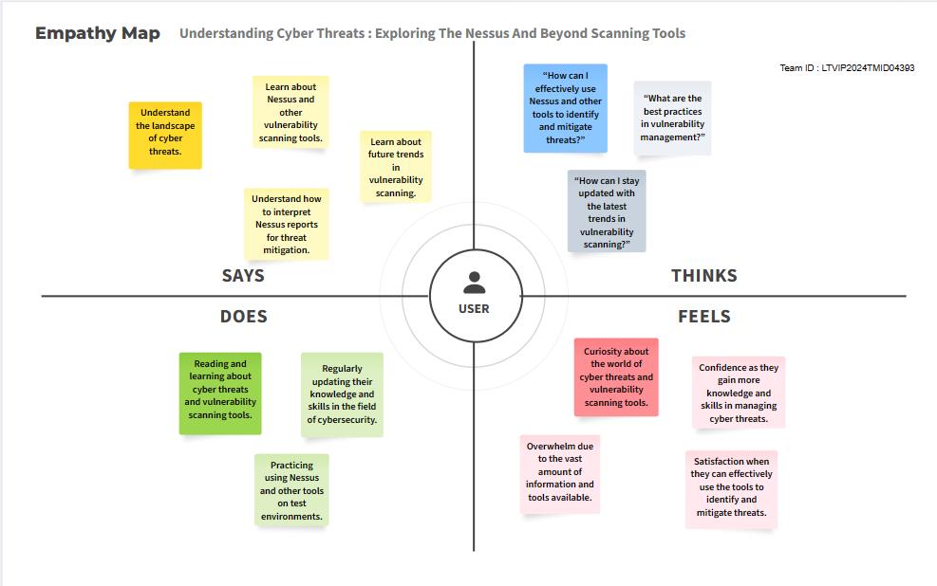

empathy map should help in understanding the user’s needs, feelings, and challenges, and guide the development of the project to ensure it is user-centered and meets the user’s goals. It’s a great tool for ensuring that the project is relevant, useful, and engaging for the intended audience.

## BRAINSTORMING AND IDEA PRIORITIZATION

Brainstorming for the topic of “**Understanding Cyber Threats: Exploring the Nessus and Beyond Scanning Tools”**

* **Understanding Cyber Threats**: Start with a comprehensive overview of cyber threats. Discuss different types of threats such as malware, phishing, ransomware, and DDoS attacks. Explain how these threats exploit vulnerabilities in systems.
* **Introduction to Nessus**: Provide a detailed introduction to Nessus. Discuss its features, capabilities, and why it is a popular tool for vulnerability scanning.
* **Working with Nessus**: Dive into the practical aspects of using Nessus. Discuss how to set up Nessus, perform scans, and interpret the results. Include screenshots or diagrams to help explain the process.
* **Beyond Nessus - Other Scanning Tools**: Explore other vulnerability scanning tools in the market. Compare and contrast these tools with Nessus in terms of features, ease of use, and effectiveness.
* **Case Studies**: Include real-world case studies where Nessus and other tools have been used to detect and mitigate cyber threats. Discuss the challenges faced and how they were overcome.
* **Future Trends**: Discuss emerging trends in the field of vulnerability scanning and cyber threat management. This could include the use of AI and machine learning in vulnerability detection, the integration of vulnerability scanning with other security practices, and the growing importance of continuous monitoring and real-time threat intelligence.
* **Conclusion**: Summarize the key points discussed in the paper. Highlight the importance of understanding cyber threats and using tools like Nessus to protect against them.
* **Recommendations**: Provide recommendations for organizations on how to effectively use Nessus and other tools to manage cyber threats. Discuss the importance of regular scanning, timely patching, and continuous monitoring.

**Problems Identified**

Here are some potential challenges identified in the context of “Understanding Cyber Threats: Exploring the Nessus and Beyond Scanning Tools”

* **Accuracy and False Positives**: AI and machine learning technologies can enhance the precision of vulnerability detection, but they may also result in false positives. This could potentially make the scanning process less efficient and overlook actual threats.
* **Integration with Other Security Practices**: For a holistic view of an organization’s security posture, vulnerability scanning tools need to be integrated with other security practices. However, this integration can be intricate and difficult.
* **Continuous Monitoring and Real-Time Threat Intelligence**: The demand for continuous monitoring and real-time threat intelligence is increasing. However, not all tools may have these capabilities, and those that do may not provide them in a user-friendly or efficient way.
* **Automation and Scalability**: As organizations expand and their networks become more complicated, there is a need for automated and scalable vulnerability scanning solutions. However, some tools may not have adequate automation or scalability features.
* **Regulatory Compliance**: Regular vulnerability scanning can assist organizations in demonstrating compliance with regulations. However, understanding and keeping up with these regulations can be challenging.
* **Quality of Tools**: Numerous vulnerability scanning tools are available, but not all of them are of high quality. Some tools may not offer comprehensive scanning options, may be hard to use, or may not be regularly updated to keep up with new threats.
* **Data Protection**: The use and transmission of vulnerability data with reports can pose potential threats and can lead to additional vulnerabilities if not properly protected.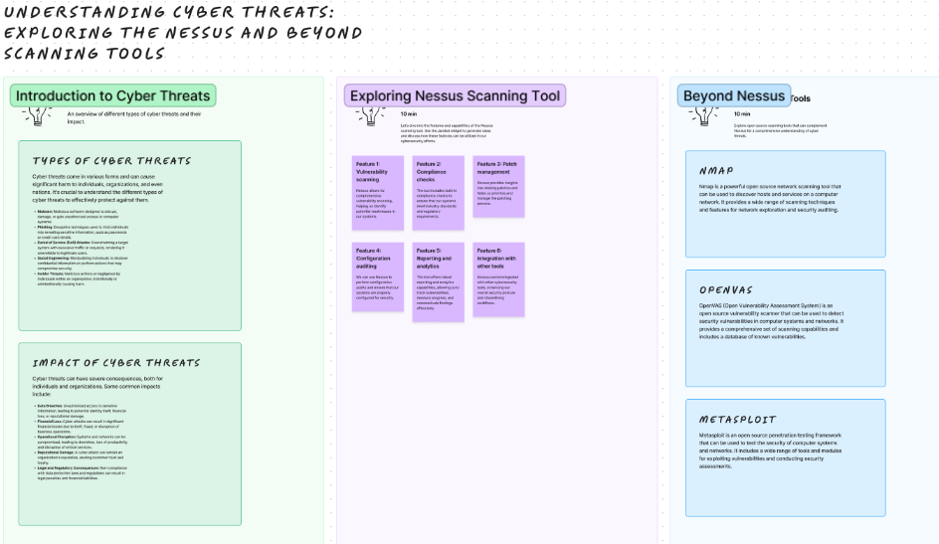

**Fig: Representing the Brainstorm idea on the topic “ Understanding Cyber Threats: Exploring Nessus and Beyond Nessus”**

**UNDERSTANDING CYBER THREATS: EXPLORING THE NESSUS AND BEYOND SCANNING TOOLS**

**1. INTRODUCTION TO CYBER THREATS AND VULNERABILITY SCANNING**

**1.1. UNDERSTANDING CYBER THREATS**

**Overview of Cyber Threats Landscape**

The cyber threat landscape encompasses all potential and identified cybersecurity risks impacting user groups, organizations, specific industries, or a given period. This landscape evolves continuously due to the emergence of new threats on a daily basis. Key factors influencing this dynamic landscape include the advancing complexity of tools and attack techniques, growing dependence on IT products and services, networks facilitating the distribution of cybercrime proceeds, and external elements like global pandemics or financial downturns.

**Common Types of Cyber Attacks**

* **Malware**: This refers to harmful software created to damage a computer, network, or server.
* **Phishing**: This is a technique used to steal sensitive information by deceiving users into entering their details on a fake website.
* **Man-in-the-Middle (MITM) Attacks**: In this type of attack, a perpetrator secretly intercepts and potentially modifies the communication between two parties who believe they are directly communicating with each other.
* **Denial-of-Service (DoS) and Distributed Denial-of-Service (DDoS) Attacks**: These attacks are designed to render a machine or network resource inaccessible to its intended users.
* **SQL Injection**: This is a method of attack used to take advantage of web applications by altering SQL queries.
* **Cross-Site Scripting (XSS)**: This is an injection attack where harmful scripts are inserted into trustworthy websites.
* **Identity-Based Attacks**: These are attacks in which the attacker pretends to be another user to carry out actions on their behalf.
* **Supply Chain Attacks**: These attacks focus on the less secure components in the supply chain network.
* **Insider Threats**: These are threats that come from within the organization, such as from employees or contractors.
* **DNS Tunneling**: This is a cyber attack method that involves encoding the data of other programs or protocols in DNS queries and responses.
* **IoT-Based Attacks**: These are attacks that focus on Internet of Things (IoT) devices.

**Importance of Vulnerability Scanning**

Vulnerability scanning is essential for a multitude of reasons. It provides organizations with the ability to precisely evaluate their security stance by detecting possible vulnerabilities in their systems and applications. This empowers them to rank their remediation tasks and distribute resources more efficiently to avert security breaches, lessen the severity of attacks, and dodge financial damages. Conducting vulnerability scans on a regular basis can also assist organizations in adhering to industry rules and security norms, as numerous frameworks necessitate vulnerability evaluations. The deployment of automated scanning signifies an organization’s dedication to data security, inspires trust in stakeholders, and bolsters the entirety of their security precautions.

**1.2. INTRODUCTION TO NESSUS**

Nessus, a vulnerability scanner, was originally developed as a complimentary tool by Renaud Deraison in 1998. However, it transitioned into a proprietary product in 2005 following the introduction of Nessus 3 and the establishment of Tenable, Inc., a cybersecurity firm that Deraison co-founded.

**Overview of Nessus Scanning Tool**

[Nessus is a remote security scanning tool that scans a computer and raises an alert if it discovers any vulnerabilities that malicious hackers could use to gain access to any computer you have connected to a network](https://www.cs.cmu.edu/~dwendlan/personal/nessus.html). [It performs its scans by utilizing plugins, which run against each host on the network to identify vulnerabilities](https://www.infosecinstitute.com/resources/penetration-testing/a-brief-introduction-to-the-nessus-vulnerability-scanner/).

**Features and Capabilities**

Nessus offers a wide range of features:

* [**High-speed asset discovery**: Nessus can quickly identify all the devices connected to your network](https://www.tenable.com/sites/drupal.dmz.tenablesecurity.com/files/datasheets/NessusPro-%28DS%29-EN-v4.pdf).
* [**Configuration auditing**: It can check the configuration of devices against best practices](https://www.tenable.com/sites/drupal.dmz.tenablesecurity.com/files/datasheets/NessusPro-%28DS%29-EN-v4.pdf).
* [**Target profiling**: Nessus can gather a lot of information about the devices on your network](https://www.tenable.com/sites/drupal.dmz.tenablesecurity.com/files/datasheets/NessusPro-%28DS%29-EN-v4.pdf).
* [**Malware detection**: It can identify devices infected with malware](https://www.spiceworks.com/it-security/data-security/articles/what-is-nessus-scanner/).
* [**Sensitive data discovery**: Nessus can find sensitive data that is stored insecurely](https://www.spiceworks.com/it-security/data-security/articles/what-is-nessus-scanner/).
* [**Scheduled security audits**: Nessus allows you to schedule security audits to ensure continuous security monitoring](https://www.itperfection.com/network-security/network-monitoring/what-is-nessus-and-how-does-it-work-network-munitoring-vulnerabilit-scaning-security-data-windows-unix-linux/).
* [**Detection of missing security updates and patches**: Nessus can identify software that is missing important security updates or patches](https://www.itperfection.com/network-security/network-monitoring/what-is-nessus-and-how-does-it-work-network-munitoring-vulnerabilit-scaning-security-data-windows-unix-linux/).

**Installation and Setup Process**

To set up Nessus, begin by obtaining the appropriate Nessus package from the Tenable Downloads site, tailored to your operating system and processor. Once downloaded, locate the folder containing the Nessus installer and initiate the installation process by double-clicking the file. Follow the prompts provided by the installation wizard to finalize the setup. Upon completion, launch Nessus and initiate a scan.

**Installation Process**

First you have to register with the first name, last name and business email address to get access to download the Nessus essential, because Nessus essential provides us more features with free of cost.

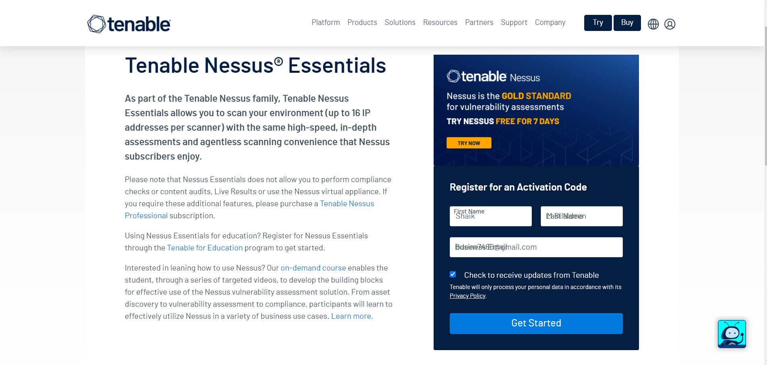

**Fig:1.2.1. Tenable Nessus Essential Registration Page**

After entering the details we will be redirected to download page and will be provided with a activation key to our email which was given there

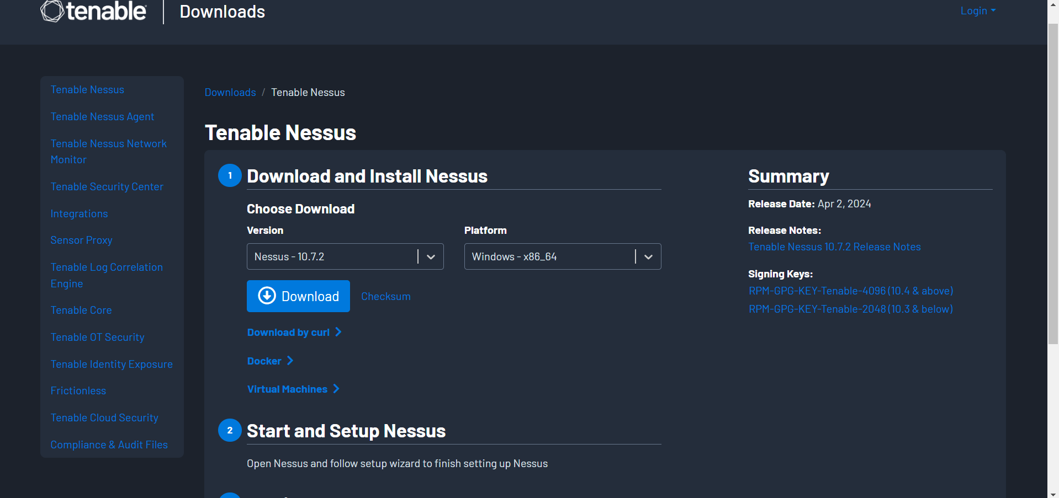

**Fig:1.2.2. Tenable Nessus Download Page After Registration**

Enter download to start the download of the Nessus and then we want to give the option we want to select. After the download is complete we have to setup the tenable Nessus 10.7x in order to function properly by choosing correct plugins.

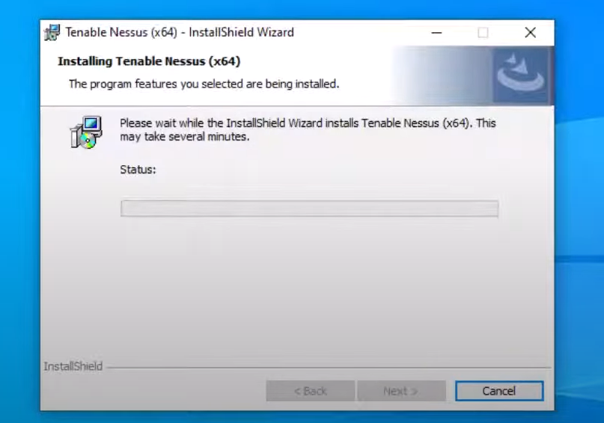

**Fig:1.2.3. Tenable Nessus Installation Processing**

Once it is finished installation, we have to click on **finish** which is shown in below figure

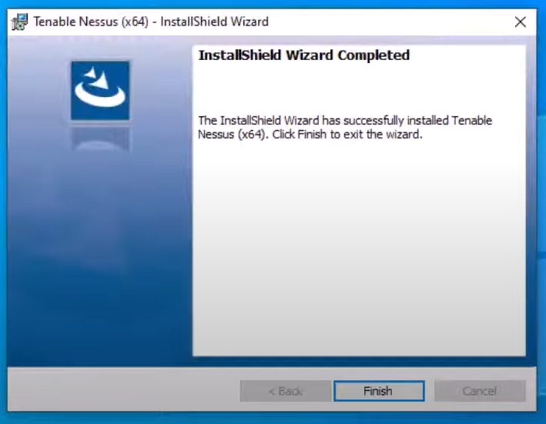

**Fig:1.2.4. Tenable Nessus Installation Process Completed**

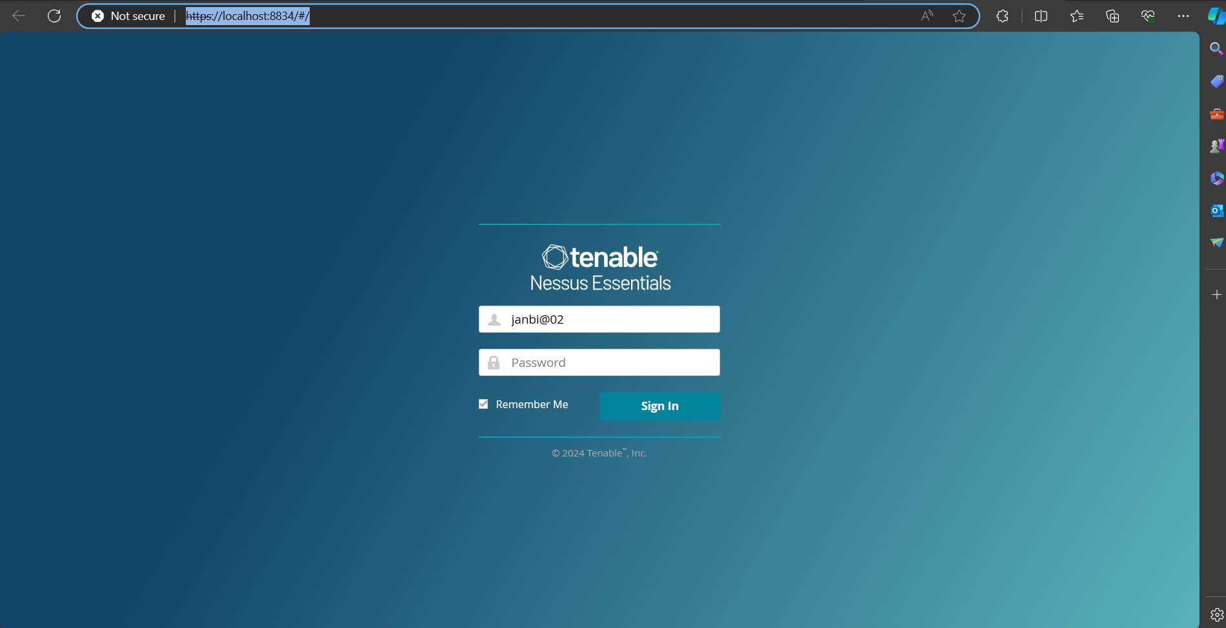

**Fig:1.2.5. Tenable Login Page**

After the installation is successfully completed you will be directed to the registration page from the Nessus web-client page , where you have to click on continue without check the offline registration and next have to select the Nessus essentials from the options given below and have to click continue in order to enter the first name, last name and work mail in order to generate the activation code, but there is an option to skip this activation code generation by doing the registration first as mentioned in the first process to get the activation code, then enter the activation code and click on continue and you will be asked to create an username and password in order to access it later through authentication and authorization technique, then the initializing of the Nessus through dumping the necessary plugins takes place and finally the workspace opens as shown in below figure.

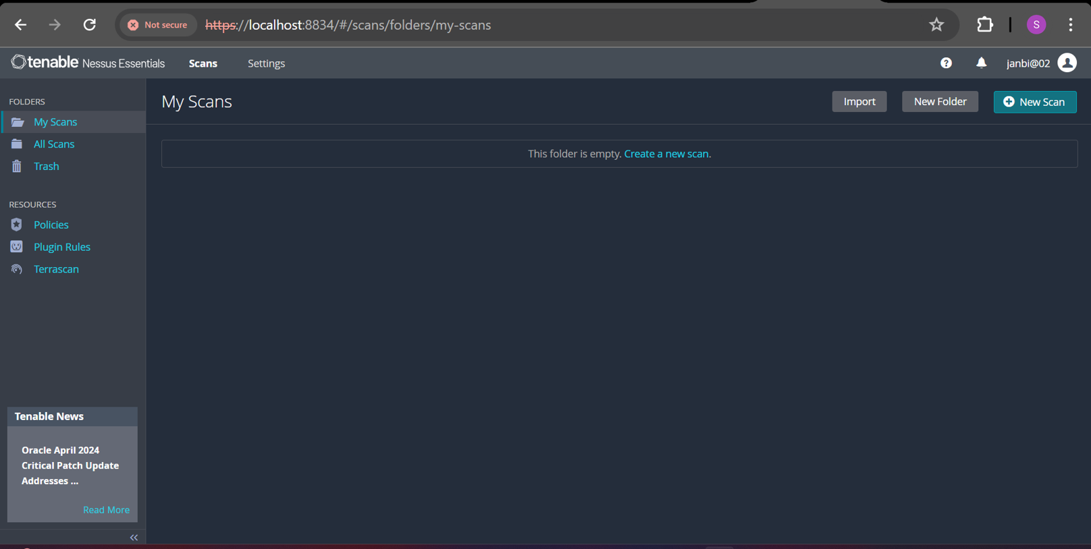

**Fig:1.2.6. Tenable Nessus Essential Interface**

**Licensing Options**

Nessus comes in two editions: Nessus Professional and Nessus Expert. With Nessus Professional, you get access to all features at a fixed subscription rate. Meanwhile, Nessus Expert offers a subscription rate along with any extra web application scanning or external attack surface scanning (EASM) domains beyond five per quarter.

**Basic Scanning Techniques**

To conduct a fundamental scan using Nessus, initiate the process by creating a scan and selecting an appropriate scan template. Proceed to configure the scan settings accordingly. For more comprehensive scanning, you have the option to set up credentials. Once the settings are configured, launch the scan. Upon completion of the scan, review the results and generate a report. It's important to note that this overview provides a basic understanding; for detailed guidance, refer to the official Nessus documentation or online tutorials.

**1.3. BEYOND NESSUS : OVERVIEW OF OTHER SCANNING TOOLS**

**Introduction to Other Vulnerability Scanning Tools**

Numerous alternative vulnerability scanning tools are available as substitutes for Nessus. Among them are Metasploit, OpenVAS, PhoneSploit Pro, Sucuri, Intruder, OpenSCAP, Acunetix, Invicti, SecPod SanerNow, ManageEngine, and Code42.

**Comparison with Nessus**

Nessus stands out as a popular vulnerability scanning solution, renowned for its extensive scanning features and broad compatibility across various operating systems and devices. Here's a comparison with some alternative tools.

* **OpenVAS**: While Nessus is a proprietary tool, OpenVAS is open-source. [However, OpenVAS may require more manual work to deploy and operate](https://www.tenable.com/nessus/competitive-comparison).
* [**Rapid7 Nexpose**: Nexpose integrates with other Rapid7 tools for a more cohesive ecosystem, while Nessus integrates with various SIEM tools and Tenable’s SecurityCenter](https://www.digitalsecurity.blog/post/comparing-vulnerability-management-tools-nessus-vs-nexpose).
* **Retina**: Both Nessus and Retina are popular network vulnerability scanning tools. [The comparison between them is usually based on their ability to search, scanning time, and the ability to detect vulnerabilities](https://stumejournals.com/journals/confsec/2017/2/69/pdf).

**Advantages and Disadvantages of Alternative Tools**

Vulnerability scanning tools have their own strengths and weaknesses. Here are some general pros and cons.

**Advantages**:

* [**Fast results:** Automated scanning tools generate results relatively quickly](https://www.computest.nl/en/knowledge-platform/blog/what-are-pros-and-cons-vulnerability-scanning-tools/).
* [**Repeatable:** An automated vulnerability scan is easy to repeat](https://www.computest.nl/en/knowledge-platform/blog/what-are-pros-and-cons-vulnerability-scanning-tools/).
* [**User-friendly**: Most tools have a clear interface and are easy to use](https://www.computest.nl/en/knowledge-platform/blog/what-are-pros-and-cons-vulnerability-scanning-tools/).
* [**Constant monitoring:** A vulnerability scanning tool can be deployed effectively for constant monitoring](https://www.computest.nl/en/knowledge-platform/blog/what-are-pros-and-cons-vulnerability-scanning-tools/).

**Disadvantages**:

* [**Limited coverage:** A vulnerability scanning tool may not find all vulnerabilities](https://www.computest.nl/en/knowledge-platform/blog/what-are-pros-and-cons-vulnerability-scanning-tools/).
* [**Constant updates required**: To ensure that the most recent vulnerabilities are found, you need to make sure the tool is continually updated](https://www.computest.nl/en/knowledge-platform/blog/what-are-pros-and-cons-vulnerability-scanning-tools/).
* [**False positives:** You may often be faced with false positives, which can make interpreting the results a time-consuming business](https://www.computest.nl/en/knowledge-platform/blog/what-are-pros-and-cons-vulnerability-scanning-tools/).

**Use Cases for Different Scanning Tools**

Different tools are suited for different use cases:

* [**Cloud-Based Vulnerability Scanners**: Used to find vulnerabilities within cloud-based systems such as web applications](https://phoenixnap.com/blog/vulnerability-assessment-scanning-tools).
* [**Host-Based Vulnerability Scanners**: Used to find vulnerabilities on a single host or system](https://www.computest.nl/en/knowledge-platform/blog/what-are-pros-and-cons-vulnerability-scanning-tools/).
* [**Network-Based Vulnerability Scanners**: Used to find vulnerabilities in an internal network by scanning for open ports](https://phoenixnap.com/blog/vulnerability-assessment-scanning-tools).
* [**Database-Based Vulnerability Scanners**: Used to find vulnerabilities in database management systems](https://phoenixnap.com/blog/vulnerability-assessment-scanning-tools).

**Considerations for Tool Selection**

When selecting a vulnerability scanning tool, consider the following:

* [**Vulnerability Type**: Different tools may be better suited for different types of vulnerabilities](https://phoenixnap.com/blog/vulnerability-assessment-scanning-tools).
* [**Budget**: The cost of the tool can be a significant factor](https://www.computest.nl/en/knowledge-platform/blog/what-are-pros-and-cons-vulnerability-scanning-tools/).
* [**Update Frequency**: How often the tool is updated can affect its effectiveness](https://www.computest.nl/en/knowledge-platform/blog/what-are-pros-and-cons-vulnerability-scanning-tools/).
* [**Reputation and Customer Service**: The tool’s reputation and the quality of customer service can also be important factors](https://www.getastra.com/blog/security-audit/vulnerability-assessment-scanning-tools/).

**1.4. IMPORTANCE OF VULNERABILITY MANAGEMENT**

Vulnerability management plays a pivotal role in upholding security standards. It entails the ongoing surveillance and evaluation of systems, networks, and applications to pinpoint potential security threats. Through the identification, assessment, and remediation of these vulnerabilities, organizations can proactively thwart attacks and mitigate the impact of any potential breaches. The ultimate objective of vulnerability management is to curtail the organization's risk exposure by addressing as many vulnerabilities as feasible.

**Role of Vulnerability Management in Cybersecurity**

Vulnerability management holds significant importance within cybersecurity practices. It encompasses the detection of threats, risk identification, policy establishment, compliance monitoring, and solution implementation to safeguard assets against malicious intrusions. The primary objective of vulnerability management is to reduce an organization's attack surface, which refers to the range of potential security vulnerabilities and entry points that could be exploited by malicious entities to execute cyberattacks.

**Benefits of Proactive Vulnerability Scanning**

Proactive vulnerability scanning offers several benefits:

* [**Early Detection of Weaknesses**: Vulnerability scanners allow organizations to identify security weaknesses and flaws in their systems, networks, and applications before they are exploited by malicious actors](https://secureframe.com/blog/vulnerability-scanning).
* [**Efficient Risk Management**: Vulnerability scanning helps organizations prioritize and triage the security vulnerabilities present in their IT environment so they can see the most result from their efforts](https://www.enterprotect.com/resource-center/the-fundamentals-of-vulnerability-management).
* **Compliance and Regulatory Adherence**: Many regulatory and industry standards require vulnerability assessments. [Implementing automated scanning demonstrates a commitment to data protection, instills confidence in stakeholders, and strengthens overall security measures](https://www.enterprotect.com/resource-center/the-fundamentals-of-vulnerability-management).
* [**Time and Cost Savings**: Regular vulnerability scans measure your IT hygiene as it identifies how effective your security measures are](https://www.enterprotect.com/resource-center/the-fundamentals-of-vulnerability-management).

**Challenges in Vulnerability Management**

There are several challenges in vulnerability management:

* [**Incomplete Asset Inventory**: For vulnerability management programs to effectively reduce risk, organizations must have visibility into the systems and applications that exist within their technology environment](https://www.enterprotect.com/resource-center/the-fundamentals-of-vulnerability-management).
* **Overwhelming Scope**: The average organization identifies a large number of vulnerabilities when running a scan. [Over any six months, roughly 28% of these remain unmitigated](https://www.enterprotect.com/resource-center/the-fundamentals-of-vulnerability-management).
* [**Prioritizing Vulnerabilities**: Even the list of critical vulnerabilities identified by a scan is often too long to fully address](https://www.enterprotect.com/resource-center/the-fundamentals-of-vulnerability-management).
* [**Manual Processes and Lack of Automated Response**: Many of the processes surrounding vulnerability prioritization and remediation are manual, making them difficult to scale and prone to human error](https://www.enterprotect.com/resource-center/the-fundamentals-of-vulnerability-management).

**Compliance and Regulatory Considerations**

When formulating vulnerability management protocols, it's crucial to take into account compliance and regulatory mandates. Various sectors have specific regulations dictating the adoption of security protocols, including vulnerability management procedures. Failure to adhere to these guidelines can result in penalties, fines, and sanctions for organizations.

**Integration with Other Security Processes**

Incorporating other security tools like intrusion detection systems (IDS) and security information and event management (SIEM) systems can offer a holistic perspective of your security status. This integration facilitates the correlation of data from various systems, simplifying the process of identifying vulnerabilities and threats throughout your network.

**1.5. UNDERSTANDING NESSUS REPORTS**

## Structure of Nessus Reports

The structure of Nessus reports is designed to offer a thorough overview of the vulnerabilities uncovered during a scan. These reports are exportable in various formats, including Tenable Nessus file, Tenable Nessus DB file, PDF, HTML, and CSV. They typically consist of multiple sections, such as Hosts Summary, Vulnerabilities by Host, and Vulnerabilities by Plugin. Each vulnerability is stored within a <ReportItem> block, contained within a <ReportHost> block, representing a scanned host.

## Key Elements and Findings

[Key elements in a Nessus report include the list of targets, policies defined by the user, and scan results](https://docs.tenable.com/nessus/Content/ScanReportFormats.htm). [Nessus reports provide detailed data for analysts to measure and track the accuracy and performance of Nessus scans](https://www.tenable.com/sc-report-templates/nessus-scan-summary-report). [They include a list of vulnerabilities, their descriptions, severity ratings, and recommendations for mitigation](https://www.devopsschool.com/blog/what-is-nessus-and-use-cases-of-nessus/). [Some reports focus on specific types of vulnerabilities, such as exploitable vulnerabilities](https://docs.tenable.com/nessus/Content/ScanResults.htm).

## Common Vulnerabilities and Exposures (CVEs)

Common Vulnerabilities and Exposures (CVEs) are a standard for identifying vulnerabilities. [Tenable maintains a list of CVEs and their affected products, and augments the data to include related Tenable Plugins that detect each vulnerability](https://www.tenable.com/cve). [Nessus reports can include information about CVEs associated with the detected vulnerabilities](https://docs.tenable.com/nessus/Content/ScanResults.htm).

## Prioritization of Vulnerabilities

[Nessus assigns severity levels to identified vulnerabilities, helping organizations prioritize and focus on the most critical issues first](https://www.devopsschool.com/blog/what-is-nessus-and-use-cases-of-nessus/). [It provides a Vulnerability Priority Rating (VPR) the first time you scan a vulnerability on your network](https://docs.tenable.com/nessus/Content/ScanResults.htm). [Tenable recommends resolving vulnerabilities with the highest VPRs first](https://docs.tenable.com/nessus/Content/RiskMetrics.htm). [Nessus also identifies exploitable vulnerabilities present in your scan results](https://www.tenable.com/nessus-reports/exploitable-vulnerabilities-report).

## Interpretation of Scan Results

[Interpreting Nessus scan results involves understanding your organization’s security posture and vulnerabilities](https://docs.tenable.com/nessus/Content/ScanResults.htm). [Color-coded indicators and customizable viewing options allow you to customize how you view your scan’s data](https://docs.tenable.com/nessus/Content/ScanResults.htm). [You can view scan results in several views, including Compliance, Dashboard, History, Hosts, Notes, Records, Remediations, and Scan Summary](https://docs.tenable.com/nessus/Content/ScanResults.htm). [Comparing scan results can help you see how a given system or network has changed over time](https://docs.tenable.com/nessus/Content/CompareScanReportResults.htm).

**2. PLANNING AND PREPARATION**

**2.1 PLANNING THE ENVIRONMENT**

Planning the environment for vulnerability scanning involves setting up the necessary infrastructure, tools, and configurations to conduct scans effectively and efficiently. Here are detailed notes on planning the environment for vulnerability scanning

**Assessment of Infrastructure**

Assess the current infrastructure to pinpoint assets and systems necessitating scanning, covering servers, workstations, network devices, databases, and other IT components within the organization.

**Mapping Network Topology**

Develop a thorough map of the organization's network topology to comprehend the arrangement of interconnected devices and sections. This aids in pinpointing potential entry points for attackers and ensures comprehensive coverage during vulnerability scanning.

**Network Segmentation and Isolation:**

Divide the network into logical zones considering data sensitivity, user roles, and security needs. Isolate critical systems and sensitive assets to mitigate the impact of vulnerabilities and unauthorized access.

**Selection of Scanning Tools:**

Select suitable vulnerability scanning tools based on organizational needs, budget, and technical capabilities. Consider factors such as support for various vulnerability types, scalability, user-friendliness, and integration with existing security infrastructure.

**Configuring Tools:**

Adjust the chosen scanning tools to align with the organization's scanning objectives and network setup. This involves specifying scanning parameters, setting up authentication credentials for system access, and scheduling scans.

**Credential Management:**

Establish a centralized system to manage authentication credentials used in vulnerability scanning. Tasks may include securely storing credentials, regularly updating passwords, and limiting access to authorized personnel.

**Setting Up a Test Environment:**

Create a dedicated test environment to conduct preliminary scans and validate scanning configurations before executing scans in the production environment. Ensure this environment closely mirrors the production setup for accurate results.

**Baseline Establishment**

Establish a baseline of normal network behavior and system configurations to differentiate between legitimate activities and potential security threats during vulnerability scanning. This baseline helps in identifying deviations that may indicate the presence of vulnerabilities or anomalies.

**Performance Optimization**

Optimize scanning performance to minimize disruption to business operations and network performance. This may involve scheduling scans during off-peak hours, adjusting scanning parameters to reduce resource utilization, and prioritizing critical systems for scanning.

**Compliance Requirements**

Ensure that the vulnerability scanning environment complies with relevant regulatory requirements and industry standards. This may include maintaining audit trails of scanning activities, protecting sensitive scan data, and implementing controls to prevent unauthorized access to scanning tools and results.

**Monitoring and Logging**

Implement monitoring and logging mechanisms to track scanning activities, detect anomalies, and generate alerts for suspicious behavior. This helps in identifying and responding to security incidents in a timely manner.By carefully planning the vulnerability scanning environment, organizations can effectively identify and address security vulnerabilities within their IT infrastructure, reducing the risk of data breaches and cyberattacks.

**2.2 SCOPING THE SCAN**

Scoping the scan is a critical step in vulnerability scanning as it defines the boundaries, targets, and objectives of the scanning process. Here are detailed notes on scoping the scan for vulnerability scanning

**Identify Assets**

Begin by identifying all assets within the organization's IT infrastructure that are to be included in the vulnerability scan. This includes servers, workstations, network devices, databases, and any other components that may be connected to the network.

**Define Scope Boundaries**

Clearly define the scope boundaries to determine what will be included and excluded from the vulnerability scan. Consider factors such as network segments, geographic locations, and ownership of assets when defining the scope.

**Prioritize Assets**

Prioritize assets based on their criticality to the organization's operations and the sensitivity of the data they store or process. Focus on scanning high-value assets and critical systems first to identify and remediate vulnerabilities that pose the greatest risk.

**Consider Compliance Requirements**

Take into account any regulatory requirements or industry standards that dictate the scope of the vulnerability scan. Ensure that the scanning scope aligns with compliance mandates such as PCI DSS, HIPAA, GDPR, or industry-specific regulations.

**Include Third-party Systems**

If the organization relies on third-party systems or cloud services, ensure that these systems are included in the scanning scope. Coordinate with third-party vendors to obtain necessary permissions and ensure compliance with service agreements.

**Account for Network Segmentation**

Consider the organization's network segmentation strategy when scoping the vulnerability scan. Scan each network segment separately to ensure comprehensive coverage and identify vulnerabilities that may be present in isolated segments.

**Account for System Availability**

Take into account the availability of systems and networks when scheduling vulnerability scans. Coordinate with system owners and stakeholders to minimize disruptions to business operations and ensure that critical systems are scanned during off-peak hours.

**Include Testing Environment**

Include the organization's testing environment in the scanning scope to identify vulnerabilities in pre-production systems before they are deployed to the live environment. This helps in addressing security issues early in the development lifecycle.

**Document Scope Decisions**

Document the decisions made regarding the scope of the vulnerability scan, including the rationale behind inclusion/exclusion of assets, prioritization criteria, and any compliance considerations. This documentation serves as a reference for stakeholders and helps ensure clarity and accountability.

**Review and Refine Scope**

Periodically review and refine the scanning scope to adapt to changes in the organization's IT infrastructure, business requirements, or regulatory landscape. Stay agile and responsive to emerging threats and evolving security challenges.By carefully scoping the vulnerability scan, organizations can ensure that the scanning process is focused, targeted, and aligned with their security objectives, ultimately leading to more effective identification and remediation of vulnerabilities within their IT environment.

**2.3 COMPLIANCE AND REGULATORY REQUIREMENTS**

Compliance and regulatory requirements play a significant role in shaping how organizations conduct vulnerability scanning to ensure the security of their IT infrastructure. Here are detailed notes on compliance and regulatory requirements related to vulnerability scanning

**Industry-specific Standards**

Various industries have established standards and regulations that govern cybersecurity practices, including vulnerability scanning. For example:

* *Payment Card Industry Data Security Standard* (PCI DSS): Requires organizations that handle payment card data to conduct regular vulnerability scans and penetration tests.
* *Health Insurance Portability and Accountability Act* (HIPAA): Mandates vulnerability assessments as part of the security risk analysis process for protected health information (PHI).
* *General Data Protection Regulation* (GDPR): Requires organizations to implement appropriate security measures, including vulnerability assessments, to protect personal data of EU citizens.

**Government Regulations**

Government agencies may impose regulations and guidelines to ensure the security of critical infrastructure and sensitive information.

For example

* *NIST Cybersecurity Framework*: Provides guidance on managing cybersecurity risks, including vulnerability assessment and mitigation.
* *Federal Information Security Management Act* (FISMA): Requires federal agencies to conduct regular vulnerability scanning and remediation activities to protect government information systems.

**Data Protection Laws**

Data protection laws around the world often include requirements related to vulnerability scanning to safeguard personal and sensitive data. Organizations must ensure compliance with these laws when conducting vulnerability assessments.

For example

* *California Consumer Privacy Act* (CCPA): Requires businesses to implement reasonable security measures, including vulnerability assessments, to protect consumers' personal information.
* *Personal Data Protection Act* (PDPA) (Singapore): Mandates organizations to protect personal data by implementing appropriate security measures, including vulnerability assessments.

**Contractual Obligations**

Organizations may be subject to contractual obligations that require vulnerability scanning to be performed. This could include contracts with customers, partners, or vendors that stipulate compliance with specific security standards or requirements.

**Documentation and Reporting**

Compliance with regulatory requirements often involves documenting vulnerability scanning activities and reporting findings to relevant stakeholders. Organizations may need to maintain records of scan results, remediation efforts, and compliance status for auditing and regulatory purposes.

**Frequency and Timing**

Some regulations specify the frequency and timing of vulnerability scanning activities. For example, organizations may be required to conduct scans on a quarterly or annual basis or after significant changes to the IT infrastructure.

**Penetration Testing Requirements**

In addition to vulnerability scanning, certain regulations may require organizations to perform penetration testing to identify and exploit security vulnerabilities. Penetration testing goes beyond vulnerability scanning by simulating real-world attack scenarios to assess the effectiveness of security controls.

**Third-party Requirements**

Organizations may need to comply with vulnerability scanning requirements imposed by third parties, such as regulatory authorities, industry associations, or business partners. Failure to meet these requirements could result in penalties, fines, or reputational damage.By understanding and adhering to compliance and regulatory requirements related to vulnerability scanning, organizations can demonstrate their commitment to maintaining a secure and compliant IT environment while minimizing the risk of data breaches and regulatory violations.

**2.4 RESOURCE ALLOCATION AND SCHEDULING**

Resource allocation and scheduling are crucial aspects of vulnerability scanning that ensure the efficient use of personnel, tools, and infrastructure while minimizing disruption to business operations. Here are detailed notes on resource allocation and scheduling for vulnerability scanning

**Team Composition**

Determine the composition of the scanning team based on the organization's size, complexity of the IT environment, and availability of skilled personnel. The team may include security analysts, network administrators, and system engineers with expertise in vulnerability assessment tools and techniques.

**Roles and Responsibilities**

Define clear roles and responsibilities for each member of the scanning team. This includes designating a team leader or coordinator responsible for overseeing the scanning process, assigning tasks to team members, and ensuring timely completion of scans.

**Tool Selection and Configuration**

Select and configure vulnerability scanning tools based on the organization's requirements and objectives. Ensure that the chosen tools are capable of scanning the entire IT infrastructure, identifying various types of vulnerabilities, and generating actionable reports.

**Hardware and Software Resources**

Allocate sufficient hardware and software resources to support vulnerability scanning activities. This may include dedicated servers or virtual machines for hosting scanning tools, adequate storage for storing scan results, and licensed software for conducting scans.

**Network Bandwidth and Capacity**

Assess the network bandwidth and capacity to determine the impact of vulnerability scanning on network performance. Schedule scans during off-peak hours to minimize congestion and avoid disruptions to critical business operations.

**Scanning Frequency**

Determine the frequency of vulnerability scanning based on the organization's risk tolerance, compliance requirements, and operational needs. Critical systems may require more frequent scans, while less critical systems may be scanned less frequently.

**Scan Scheduling**

Develop a scanning schedule that balances the need for thorough coverage with the need to minimize disruption to business operations. Consider factors such as system availability, network traffic patterns, and maintenance windows when scheduling scans.

**Prioritization of Scans**

Prioritize vulnerability scans based on the criticality of assets, severity of vulnerabilities, and potential impact on business operations. Focus on scanning high-value assets and critical systems first to address the most significant security risks.

**Scalability and Flexibility**

Ensure that the vulnerability scanning process is scalable and flexible enough to accommodate changes in the organization's IT environment. The scanning schedule and resource allocation should be adaptable to new systems, network expansions, and evolving security requirements.

**Training and Skill Development**

Provide ongoing training and skill development opportunities for members of the scanning team to enhance their proficiency in vulnerability scanning tools and techniques. This ensures that the team remains effective in identifying and mitigating security vulnerabilities.

**Documentation and Reporting**

Document resource allocation decisions, scan schedules, and scanning results for accountability and compliance purposes. Generate comprehensive reports detailing identified vulnerabilities, remediation recommendations, and progress towards mitigating security risks.By carefully allocating resources and scheduling vulnerability scanning activities, organizations can effectively identify and mitigate security vulnerabilities within their IT infrastructure while minimizing disruptions to business operations.

**2.5 STAKEHOLDER COMMUNICATION**

Stakeholder communication is essential for ensuring transparency, alignment, and support throughout the vulnerability scanning process. Here are detailed notes on stakeholder communication for vulnerability scanning

**Identify Stakeholders**

Identify key stakeholders who have an interest or influence in the vulnerability scanning process. This may include executive leadership, IT management, system owners, security teams, compliance officers, and external auditors.

**Establish Communication Channels**

Determine the most effective communication channels for engaging with stakeholders. This may include in-person meetings, email updates, conference calls, video conferences, collaboration platforms, and dedicated communication portals.

**Define Communication Plan**

Develop a communication plan that outlines the objectives, audience, frequency, and format of stakeholder communications throughout the vulnerability scanning process. Consideration should be given to the specific needs and preferences of different stakeholders.

**Set Expectations**

Clearly communicate the purpose, scope, and expected outcomes of the vulnerability scanning process to stakeholders. Set realistic expectations regarding the timing, duration, and potential impact of scanning activities on business operations.

**Provide Regular Updates**

Provide regular updates to stakeholders on the progress of vulnerability scanning activities. This includes sharing status reports, scan results, identified vulnerabilities, remediation efforts, and any challenges or obstacles encountered during the process.

**Tailor Messages to Audience**

Tailor communication messages to the specific needs and interests of different stakeholder groups. Executive stakeholders may require high-level summaries and strategic insights, while technical stakeholders may need detailed technical information and analysis.

**Address Concerns and Questions**

Be proactive in addressing concerns, questions, and feedback from stakeholders regarding the vulnerability scanning process. Provide timely responses and clarification to ensure that stakeholders are informed and confident in the organization's approach to cybersecurity.

**Highlight Benefits and Impacts**

Highlight the benefits of vulnerability scanning in terms of enhancing cybersecurity posture, reducing risk exposure, and protecting sensitive data. Also, communicate any potential impacts of scanning activities on business continuity, system performance, and user productivity.

**Seek Stakeholder Input**

Solicit input and feedback from stakeholders regarding the vulnerability scanning process, including suggestions for improvement and areas of concern. Engage stakeholders in decision-making and problem-solving to foster collaboration and ownership.

**Educate Stakeholders**

Provide educational resources and awareness materials to help stakeholders understand the importance of vulnerability scanning and their role in supporting cybersecurity efforts. This may include training sessions, informational webinars, and best practice guides.

**Document Communication**

Document all stakeholder communication activities, including meeting minutes, email correspondence, and communication logs. This documentation serves as a record of engagement and can be used for reference and accountability purposes.By effectively communicating with stakeholders throughout the vulnerability scanning process, organizations can build trust, foster collaboration, and ensure alignment towards common cybersecurity goals. This ultimately enhances the organization's ability to identify and mitigate security vulnerabilities effectively.

**3. CONDUCTING VULNERABILITY SCANS**

**3.1 EXECUTING NESSUS SCANS**

**Nessus scans** are commonly used for **vulnerability assessment**. Nessus is a powerful security tool that helps identify vulnerabilities in networks, systems, and applications. The following are the steps involved in Nessus scan

**Initiating Scans**

To start a Nessus scan, you typically define the target (IP address or hostname) and configure scan options (such as port range, credentials, and scan type). Nessus then performs the scan to identify vulnerabilities.

**Configuring Scan Options**

This step involves specifying scan parameters. For example, you can choose between a basic network scan, a web application scan, or a compliance scan. You can also set credentials for authenticated scans.

**Monitoring Scan Progress**

During the scan, Nessus provides real-time progress updates. You can view the scan status, identified vulnerabilities, and any issues encountered.

**Troubleshooting Common Issues**

Sometimes scans fail due to network issues, authentication problems, or misconfigurations. Troubleshooting involves checking logs, verifying credentials, and ensuring proper network connectivity.

**Security and Efficiency**

Nessus scans should be performed securely. Use proper authentication, limit scan scope, and follow best practices. Additionally, consider scan frequency to avoid overloading systems.

**3.2 INTERPRETING SCAN RESULTS**

**Interpreting Scan Results**

When reviewing scan results, it’s essential to understand the findings and their implications. Whether you’re using Nessus or any other vulnerability assessment tool.

**Reports vs. Exports**

Decide whether you want to generate detailed reports or export raw data. [Reports offer versatility and customization, while exports (e.g., XML or CSV) are useful for further analysis or integration with other tools](https://www.tenable.com/blog/how-to-leverage-nessus-scan-reports-for-better-vulnerability-assessment).

**CVSS Score**

Common Vulnerability Scoring System (CVSS) scores provide a numerical representation of vulnerability severity. [However, remember that CVSS only considers severity and not the overall risk](https://www.tenable.com/blog/how-to-leverage-nessus-scan-reports-for-better-vulnerability-assessment). Consider other factors as well.

**Reviewing Nessus Reports**

Nessus scans provide valuable information about vulnerabilities in your environment. After identifying vulnerabilities, categorize and prioritize them. [You can use CVSS scores, but also consider other contextual factors](https://www.tenable.com/blog/how-to-leverage-nessus-scan-reports-for-better-vulnerability-assessment). Remember that false positives (incorrectly identifying a vulnerability) and false negatives (missing a real vulnerability) can occur. [Prioritize based on the actual risk to your organization](https://www.tenable.com/blog/how-to-leverage-nessus-scan-reports-for-better-vulnerability-assessment).

**Identifying Critical Vulnerabilities**

Critical vulnerabilities pose the highest risk to your systems. These might include:

* Unpatched software: Ensure timely patching.
* Misconfigurations: Address these promptly.
* [Unsecured APIs: Secure your application programming interfaces](https://www.tenable.com/blog/how-to-leverage-nessus-scan-reports-for-better-vulnerability-assessment).

Regularly assess your environment to identify new critical vulnerabilities.

**Prioritizing Vulnerabilities Based on Severity**

Prioritization is crucial to effective vulnerability management. Consider the following steps:

* [**Step 1: Identify Vulnerabilities**: Understand all potential vulnerabilities in your system](https://www.tenable.com/blog/how-to-leverage-nessus-scan-reports-for-better-vulnerability-assessment).
* **Step 2: Categorize and Prioritize**:
  + - * [Use CVSS scores (severity) but also consider exploitability, impact, and business context](https://www.tenable.com/blog/how-to-leverage-nessus-scan-reports-for-better-vulnerability-assessment).
      * [Focus on high-risk vulnerabilities first to reduce the attack surface](https://www.tenable.com/blog/how-to-leverage-nessus-scan-reports-for-better-vulnerability-assessment).

**Understanding False Positives and False Negatives**

* False positives occur when a test incorrectly indicates a condition (e.g., a security threat) that isn’t present. False negatives happen when a test misses a real condition.
* [Example: A mammogram may have a high true positive rate (detecting breast cancer) but still yield a low likelihood of cancer if false positives are considered](https://www.tenable.com/blog/how-to-leverage-nessus-scan-reports-for-better-vulnerability-assessment).
* [Distinguishing evidence from reality is crucial in vulnerability assessment](https://www.tenable.com/blog/how-to-leverage-nessus-scan-reports-for-better-vulnerability-assessment).

**Investigating Potential Security Risks**

* Regularly assess your systems for new vulnerabilities.
* Consider threat intelligence, penetration testing, and continuous monitoring.
* [Collaborate with security teams to address risks promptly](https://www.tenable.com/blog/how-to-leverage-nessus-scan-reports-for-better-vulnerability-assessment).

**3.3 ANALYZING SCAN FINDINGS**

**Analyzing Scan Findings**

When reviewing vulnerability scan results, it’s crucial to understand the findings and their implications. Whether you’re using Nessus or any other vulnerability assessment tool, consider the following steps:

* **Reports vs. Exports**: Decide whether you want to generate detailed reports or export raw data. [Reports offer versatility and customization, while exports (e.g., XML or CSV) are useful for further analysis or integration with other tools](https://www.evolvesecurity.com/blog-posts/how-to-read-a-vulnerability-scan-report).
* **CVSS Scores**: The Common Vulnerability Scoring System (CVSS) provides a numerical representation of vulnerability severity. [However, remember that CVSS only considers severity and not the overall risk](https://www.evolvesecurity.com/blog-posts/how-to-read-a-vulnerability-scan-report). Consider other factors as well.

**Assessing the Impact of Vulnerabilities**

Understanding the impact of vulnerabilities is crucial. Consider the following:

* **Risk Context**: Evaluate how a vulnerability affects your specific environment. [High-severity vulnerabilities may not always pose an equal risk to all systems](https://www.evolvesecurity.com/blog-posts/how-to-read-a-vulnerability-scan-report).
* **Business Impact**: Consider the potential consequences of exploitation. [For example, a critical vulnerability in a production server may have a higher impact than one in a test environment](https://www.evolvesecurity.com/blog-posts/how-to-read-a-vulnerability-scan-report).

**Identifying Potential Attack Vectors**

Attack vectors are the methods cybercriminals use to breach or infiltrate a victim’s network. Common attack vectors include:

* **Malware**: Exploiting software vulnerabilities to deliver malicious code.
* **Social Engineering**: Manipulating human behavior through phishing, pretexting, or other techniques.
* [**Weak Credentials**: Gaining unauthorized access due to weak or compromised passwords](https://www.evolvesecurity.com/blog-posts/how-to-read-a-vulnerability-scan-report).
* Understanding these vectors helps prioritize defenses.

**Correlating Findings with Known Threats**

Threat intelligence correlation connects the dots between different pieces of information. [It investigates relationships between threat elements (e.g., malware and threat actors) to enhance decision-making by security teams](https://www.evolvesecurity.com/blog-posts/how-to-read-a-vulnerability-scan-report). By recognizing patterns and understanding adversaries’ attack vectors, organizations can better defend against targeted attacks.

**Performing Risk Assessments**

Risk assessments systematically identify, analyze, and control hazards and risks in a situation or place. Key steps include:

* [**Identify Hazards**: Recognize potential risks in your environment](https://www.evolvesecurity.com/blog-posts/how-to-read-a-vulnerability-scan-report).
* **Assess Risks**: Evaluate the likelihood and impact of identified hazards.
* **Implement Controls**: Put measures in place to eliminate or mitigate risks.
* **Reassess with Controls**: Review risks after implementing controls.
* [**Confirm Reduced Risk**: Ensure that risk reduction measures are effective](https://www.safetynotes.net/risk-assessment/).

**3.4 ADDRESSING FALSE POSITIVES & FALSE NEGATIVES**

**Investigating False Positive Findings**

False positives occur when a vulnerability scanner incorrectly identifies a condition (e.g., a security threat) that isn’t actually present. To address false positives:

* **Review Scan Results**: Examine the specific findings flagged as false positives.
* **Verify Manually**: Cross-check the reported vulnerabilities against the actual system configuration or code.
* **Adjust Thresholds**: Fine-tune vulnerability scan settings (e.g., severity thresholds, sensitivity) to reduce false positives.

**Adjusting Scan Configurations to Reduce False Positives**

Customize your vulnerability scanner settings to minimize false positives:

* **Severity Thresholds**: Set appropriate thresholds for vulnerability severity. Adjust them based on your organization’s risk tolerance.
* **Exclude Known False Positives**: Create exclusion lists for vulnerabilities that are consistently false positives.
* **Tune Sensitivity**: Balance sensitivity to avoid excessive alerts without missing real threats.

**Identifying False Negative Findings**

False negatives occur when a vulnerability scanner misses a real vulnerability. To identify false negatives:

* **Retest Systems**: Regularly rescan systems to catch any missed vulnerabilities.
* **Manual Verification**: Manually inspect critical systems or high-risk areas.
* **Use Multiple Scanners**: Employ different scanners to cross-validate results.
* **Check for Zero-Day Vulnerabilities**: Some vulnerabilities may not be in the scanner’s database yet.

**Enhancing Scanning Techniques to Minimize False Negatives**

Improve scanning techniques to reduce false negatives:

* **Comprehensive Coverage**: Ensure your scans cover all assets, including cloud resources, containers, and IoT devices.
* **Authenticated Scans**: Use credentials to scan internal systems more thoroughly.
* **Deep Scans**: Enable deep inspection modes to find hidden vulnerabilities.
* **Custom Scripts**: Write custom scripts to detect specific issues.

**Documenting Actions Taken to Address False Results**

Maintain a record of actions taken:

* **False Positives**: Document which findings were investigated, confirmed as false positives, and excluded from further consideration.
* **False Negatives**: Record steps taken to address missed vulnerabilities.
* **Configuration Changes**: Note adjustments made to scan settings.
* **Lessons Learned**: Share insights with the security team to improve future scans.

**3.5 REPORTING AND DOCUMENTATION**

**Compiling Comprehensive Reports of Scan Findings**

When compiling reports based on vulnerability scans, it’s essential to provide a clear and concise overview of the findings. Here’s how you can create comprehensive reports:

* [**Executive Summary**: Begin with an executive summary that highlights the most critical vulnerabilities, their impact, and recommended actions](https://www.upguard.com/blog/writing-a-cybersecurity-executive-summary).
* **Detailed Vulnerability List**: Include a detailed list of all identified vulnerabilities, categorized by severity (e.g., critical, high, medium, low).
* **Technical Details**: Provide technical details for each vulnerability, including affected systems, CVSS scores, and potential attack vectors.
* **Evidence and Proof of Concept**: If possible, include evidence (screenshots, logs) and proof-of-concept demonstrations for better understanding.
* **Recommendations**: Offer actionable recommendations for remediation.

**Summarizing Key Vulnerabilities and Recommendations**

Summarizing key vulnerabilities is crucial for decision-makers and technical teams. Focus on the following

* **Critical Vulnerabilities**: Highlight vulnerabilities that pose the highest risk to your organization.
* **Business Impact**: Explain how each vulnerability affects business operations, data, or customer trust.
* **Mitigation Strategies**: Provide clear recommendations for addressing vulnerabilities (e.g., patching, configuration changes, network segmentation).

**Generating Actionable Insights for Remediation**

Remediation is the heart of vulnerability management. To generate actionable insights:

* **Prioritize**: Rank vulnerabilities based on severity, exploitability, and business impact.
* **Timeliness**: Urgently address critical vulnerabilities to reduce the attack surface.
* **Collaborate**: Engage with IT teams, developers, and system owners to implement fixes.
* **Risk Reduction**: Focus on reducing risk rather than just fixing vulnerabilities.

**Customizing Reports for Different Stakeholders**

Stakeholders have varying interests and information needs. Customize reports for different audiences:

* **Technical Teams**: Provide detailed technical information, including vulnerability specifics and recommended fixes.
* **Executives**: Offer high-level summaries, emphasizing business impact and risk reduction strategies.
* **Regulators and Auditors**: Address compliance requirements and demonstrate due diligence.
* **Investors and Customers**: Highlight efforts to protect data and maintain trust.

**Archiving Scan Reports for Future Reference and Auditing**

Properly archive vulnerability scan reports for historical reference and auditing purposes

* **Version Control**: Maintain different versions of reports to track changes over time.
* **Metadata**: Include details such as scan date, scanner used, and personnel involved.
* **Retention Period**: Follow organizational policies regarding how long to retain reports.

**4. REMEDIATION AND MITIGATION**

**4.1 PRIORITIZING REMEDIATION EFFORTS**

**Vulnerability Prioritization Based on Risk**

Vulnerability prioritization involves organizing and ranking an application’s vulnerabilities to streamline remediation efforts. It assesses each vulnerability based on several factors:

* **Severity**: How critical the vulnerability is.
* **Risk**: The likelihood of exploitation and potential impact.
* **Reachability**: Whether the vulnerability is accessible to attackers.
* **Business Criticality**: How it affects essential business functions.
* [**Potential Impact**: The consequences if the vulnerability is exploited](https://snyk.io/learn/vulnerability-remediation-process/vulnerability-prioritization/).
* **Why Is It Important?** Prioritizing vulnerabilities strategically mitigates business risk. [It’s not just about the total count of vulnerabilities; it’s about addressing the most high-risk issues first](https://snyk.io/learn/vulnerability-remediation-process/vulnerability-prioritization/).

**Business Impact Analysis (BIA)**

BIA predicts the organizational and financial impact of business disruptions. It helps create recovery strategies and identifies necessary resources for restoring operations after inevitable consequences.

* **Purpose of BIA**
* Quantify impact (e.g., maximum tolerable downtime, recovery time objectives, recovery point objectives).
* Clarify priorities and allocate resources effectively.
* [Connect employees and teams to organizational goals](https://snyk.io/learn/vulnerability-remediation-process/vulnerability-prioritization/).

**Aligning Remediation Efforts with Organizational Goals**

High-performing companies align goals throughout the organization.

* Alignment leads to faster revenue growth, increased profitability, better employee engagement, and improved customer satisfaction.
* **How to Achieve Alignment**
* Set clear organizational goals that reflect the overall strategy.
* Communicate goals consistently at all levels.
* [Connect company decisions to underlying organizational objectives](https://snyk.io/learn/vulnerability-remediation-process/vulnerability-prioritization/).

**Establishing Timelines for Remediation Activities**

* **Strategic Communication**: Regularly discuss goals in leadership meetings, team meetings, one-on-ones, and performance reviews.
* **Connect Initiatives**: Relate company initiatives and decisions to organizational goals.
* [**Consistent Leadership Buy-In**: Ensure alignment from top to bottom](https://www.quantumworkplace.com/future-of-work/how-to-align-organizational-goals).

**4.2 IMPLEMENTING SECURITY CONTROLS**

**Implementing Security Controls**

* This involves putting in place various safeguards to protect your systems and data. Examples of security controls include access controls, encryption, firewalls, and intrusion detection systems. These measures help prevent unauthorized access and mitigate risks.
* **Deploying Patches and Updates**

Keeping your software up-to-date is crucial for security. Regularly applying patches and updates helps address known vulnerabilities and ensures that your systems are protected against potential threats. Automated patch management tools can streamline this process.

**Configuring Security Settings**

Properly configuring security settings is essential. This includes:

* Setting strong passwords: Use complex passwords or passphrase-based authentication.
* Enabling two-factor authentication (2FA): Adding an extra layer of security beyond passwords.
* Restricting unnecessary access: Limit user privileges to only what is required for their roles.

**Implementing Compensating Controls**

Sometimes, it’s not possible to fully address a security risk immediately. In such cases, compensating controls can help mitigate the impact. For example:

* If a critical patch cannot be applied immediately, additional monitoring or restrictions can be put in place.
* Implementing network segmentation to isolate critical systems from less secure ones.

**Hardening Systems and Networks**

System hardening involves reducing the attack surface by:

* Disabling unnecessary services: Only enable what is needed.
* Removing default accounts: Change default credentials to unique ones.
* Applying security baselines: Follow industry best practices.
* Network hardening focuses on securing network devices and connections.
* Configuring firewalls, intrusion prevention systems (IPS), and VPNs.
* Regularly reviewing and updating firewall rules.

**Automating Security Measures Where Possible**

Automation streamlines security tasks, reduces human error, and ensures consistent implementation. Examples include:

* Automated vulnerability scans: Regularly scan systems for vulnerabilities.
* Log analysis: Automatically analyze logs for suspicious activity.
* Incident response workflows: Automate incident handling processes.

**4.3 TESTING AND VALIDATION**

**Conducting Post-Remediation Scans**

* After addressing identified vulnerabilities, it’s crucial to verify that the remediation efforts were successful. [Post-remediation scans help ensure that security holes have been fixed and that the system is now secure](https://www.ninjaone.com/blog/what-is-vulnerability-remediation-explained-with-examples/).
* These scans re-evaluate the system to confirm that vulnerabilities have been properly addressed and that no new issues have been introduced.

**Verifying the Effectiveness of Remediation Efforts**

* Remediation validation involves assessing whether the actions taken to address vulnerabilities were successful. [It ensures that the intended results have been achieved](https://www.ninjaone.com/blog/what-is-vulnerability-remediation-explained-with-examples/).
* [By retesting systems or applications, organizations can validate that the applied fixes effectively resolved the identified vulnerabilities](https://www.ninjaone.com/blog/what-is-vulnerability-remediation-explained-with-examples/).

**Validating That Vulnerabilities Have Been Addressed**

This step confirms that the vulnerabilities identified during assessments have been properly mitigated. It includes:

* Checking that security patches were applied.
* Verifying that configurations were adjusted.
* [Ensuring that security controls are functioning as intended](https://www.ninjaone.com/blog/what-is-vulnerability-remediation-explained-with-examples/).
* [Validation helps maintain the confidentiality, integrity, and availability of information](https://www.ninjaone.com/blog/what-is-vulnerability-remediation-explained-with-examples/).

**Performing Penetration Testing and Security Assessments**

* **Penetration Testing (Pen Testing)**
* Simulates real-world cyberattacks against a network or system to identify vulnerabilities.
* [Ethical hackers (white-hat hackers) attempt to exploit weaknesses, providing valuable insights into potential risks](https://www.ninjaone.com/blog/what-is-vulnerability-remediation-explained-with-examples/).
* [Pen testing helps organizations understand their security posture and discover points of exploitation](https://www.ninjaone.com/blog/what-is-vulnerability-remediation-explained-with-examples/).

**Security Assessments**

* Include various techniques such as vulnerability scanning, network discovery, and vulnerability identification.
* [Assess the overall security of an organization’s digital assets, systems, and networks](https://www.ninjaone.com/blog/what-is-vulnerability-remediation-explained-with-examples/).
* These assessments inform risk management and guide remediation efforts.

**Iterating on Remediation Strategies as Needed**

* Security is an ongoing process. Organizations should continuously monitor, test, and improve their security measures.
* If new vulnerabilities emerge or existing ones evolve, adapt remediation strategies accordingly.
* [Regular assessments and adjustments help maintain a robust and secure digital infrastructure](https://www.ninjaone.com/blog/what-is-vulnerability-remediation-explained-with-examples/).

**4.4 INCIDENT RESPONSE & CONTIGENCY PLANNING**

**Developing Incident Response Procedures**

Incident response procedures are essential for effectively handling security incidents. These procedures outline the steps to take when an incident occurs. Key components include:

* **Preparation**: Define roles, responsibilities, and communication channels. Establish a Computer Security Incident Response Team (CSIRT) with cross-disciplinary experts.
* **Detection and Analysis**: Detect incidents, analyze their impact, and assess severity.
* **Containment, Eradication, and Recovery**: Act swiftly to contain threats, eradicate them, and restore affected systems.
* **Post-Incident Activity**: Learn from the incident, update procedures, and continuously improve.
* [Following established frameworks (such as NIST or SANS) ensures a solid foundation for incident response](https://www.crowdstrike.com/cybersecurity-101/incident-response/incident-response-steps/).

**Establishing Communication Channels During Incidents**

Effective communication is critical during incidents. Consider the following channels

* **Dedicated Status Page**: Maintain a real-time status page accessible to users, providing updates on incidents.
* **Embedded Status**: Integrate incident status within your application or website.
* **Email**: Use email alerts to notify stakeholders.
* **Workplace Chat Tools**: Leverage tools like Slack for internal communication.
* [**Social Media**: Communicate with external audiences via social platforms](https://www.crowdstrike.com/cybersecurity-101/incident-response/incident-response-steps/).

**Identifying Escalation Paths**

Escalation paths define the steps to follow when an issue requires higher-level attention. Key elements include:

* **Escalation Triggers**: Identify common triggers (e.g., timeline deviations, resource constraints) that signal escalation.
* **Roles and Responsibilities**: Define who is involved at each level (project manager, team members, sponsors, clients).
* **Escalation Procedures**: Establish steps for identifying, notifying, assessing, and resolving issues.
* [**Communication Protocols**: Ensure clear communication channels for escalation](https://www.crowdstrike.com/cybersecurity-101/incident-response/incident-response-steps/).

**Creating Backups and Disaster Recovery Plans**

A **Disaster Recovery Plan (DRP)** outlines how an organization responds to unplanned incidents (e.g., power outages, cyberattacks, natural disasters). It helps restore connectivity and data after a disaster.

* **Data Backup Strategy**
* Inventory assets (hardware, software, data).
* Select backup solutions (hardware, software).
* Schedule and conduct regular backups.
* Validate data accuracy.
* [DRPs reduce downtime, recovery costs, and reputational damage](https://www.crowdstrike.com/cybersecurity-101/incident-response/incident-response-steps/).

**Training Personnel on Incident Response Protocols**

Every employee plays a role in incident response. Training ensures they:

* Recognize security incidents (phishing emails, suspicious websites).
* Report incidents promptly.
* Understand their responsibilities.
* Benefits include shorter downtimes, reduced recovery costs, and increased security awareness.
* [Ongoing training and tailored content are crucial for staying prepared](https://www.crowdstrike.com/cybersecurity-101/incident-response/incident-response-steps/).

**4.5 CONTINUOUS MONITORING & IMPROVEMENT**

[Continuous monitoring is the ongoing detection of risks and problems within IT environments](https://www.splunk.com/en_us/blog/learn/continuous-monitoring.html). [It emphasizes real-time detection of risks, proactive response to monitoring data, and the ability to collect and analyze all data](https://www.splunk.com/en_us/blog/learn/continuous-monitoring.html). [The steps for implementing continuous monitoring include identifying potential processes or controls, defining the control objectives, defining a series of automated tests that will highlight success or failure of each assertion, determining the process frequencies, and creating processes for managing the generated alarms](https://www.splunk.com/en_us/blog/learn/continuous-monitoring.html).

**Reviewing and Updating Vulnerability Management Policies**

[Vulnerability management is a process organizations use to identify, analyze, and manage vulnerabilities within their operating environment](https://www.splunk.com/en_us/blog/learn/continuous-monitoring.html). Regularly reviewing and updating your vulnerability management policy is crucial. [New requirements may have come up, or your goals and objectives may have changed](https://www.splunk.com/en_us/blog/learn/continuous-monitoring.html). [All organizations should review and refresh their vulnerability management policies and playbooks, refer to the catalog of known exploited vulnerabilities, and establish a more aggressive turnaround time to protect their networks against urgent, active threats](https://www.splunk.com/en_us/blog/learn/continuous-monitoring.html).

**Conducting Periodic Security Assessments**

Periodic security assessments are essential for maintaining an organization’s cybersecurity posture. [They collect and analyze vast amounts of security-related data from various sources within an organization’s IT infrastructure](https://www.splunk.com/en_us/blog/learn/continuous-monitoring.html). [Conducting regular assessments will not only illuminate holes in your defenses and your security architecture; it will also validate your efforts to plug them](https://www.splunk.com/en_us/blog/learn/continuous-monitoring.html). [Assessing and validating this on a regular basis makes it easier to defend your network and reduces your risk](https://www.splunk.com/en_us/blog/learn/continuous-monitoring.html).

**Incorporating Lessons Learned into Future Scanning Activities**

[Lessons learned are reflections on past experiences that help you avoid repeating mistakes and improve your processes and outcomes](https://www.splunk.com/en_us/blog/learn/continuous-monitoring.html). [By recognizing the significance of staying updated and informed, organizations and individuals can adapt their security strategies to effectively mitigate risks, protect valuable assets, and maintain a strong defense against cyber attacks](https://blog.bugzero.io/emerging-threats-and-vulnerabilities-18050a76af29). [When working on the next project you should ensure to review previous relevant lessons learned to inform planning and execution](https://www.splunk.com/en_us/blog/learn/continuous-monitoring.html).

**Staying Informed About Emerging Threats and Vulnerabilities**

[By staying informed about emerging threats and vulnerabilities, organizations can be proactive in safeguarding their IT environments](https://www.isaca.org/resources/isaca-journal/issues/2023/volume-5/leveraging-threat-intelligence-to-proactively-mitigate-emerging-cybervulnerabilities). [Integrating threat intelligence into a cybersecurity strategy is crucial for enhancing threat detection and vulnerability management efforts](https://www.isaca.org/resources/isaca-journal/issues/2023/volume-5/leveraging-threat-intelligence-to-proactively-mitigate-emerging-cybervulnerabilities). [Leveraging these resources, organizations can stay current on trending threats and proactively defend against potential attacks and adversaries](https://www.ibm.com/blog/siem-and-threat-intelligence-stay-current-on-trending-threats/).

**5.INTEGRATION AND AUTOMATION**

**5.1. INTEGRATING WITH SECURITY INFORMATION AND EVENT MANAGEMENT (SIEM) SYSYTEMS**

**Leveraging SIEM tools for centralized monitoring**

Security Information and Event Management (SIEM) systems are crucial for centralized monitoring of security events across an organization’s network. [They collect and aggregate log data generated throughout the organization’s technology infrastructure, from host systems and applications to network and security devices such as firewalls and antivirus filters](https://docs.tenable.com/nessus-network-monitor/Content/SIEMAnalysisSection.htm).

**Integrating Nessus and other scanning tools with SIEM**

 Nessus, a widely used vulnerability scanner, can be integrated with SIEM systems. [This integration allows organizations to import data from SIEM providers to evaluate events that may warrant re-scanning the affected hosts](https://docs.tenable.com/nessus-network-monitor/Content/SIEMAnalysisSection.htm). [The SIEM Analysis section of Nessus helps track and understand SIEM-related events occurring in your system](https://docs.tenable.com/nessus-network-monitor/Content/SIEMAnalysisSection.htm). [Other security tools and platforms can also be integrated with SIEM systems for streamlined workflows, automated response actions, and centralized visibility](https://www.knowledgehut.com/blog/security/nessus-scanner).

**Correlating vulnerability data with security events**

Correlation in cybersecurity refers to the process of linking and analyzing different security events generated by various systems and devices. [It helps to identify and prioritize the events that may indicate a potential cyber attack](https://cyberpedia.reasonlabs.com/EN/event%20correlation.html). [Good and bad uses of vulnerability data for IDS event correlation have been discussed in detail by Tenable](https://www.tenable.com/blog/good-and-bad-uses-of-vulnerability-data-for-ids-event-correlation).

**Streamlining incident detection and response**

  Streamlining incident detection and response is crucial for effective cybersecurity management. [This involves coordinating various security tools, teams, and processes to effectively detect, investigate, and mitigate security incidents](https://securityzap.com/incident-response-orchestration-streamlining-incident-handling/). [Automated incident response strategies, often called SOAR (security orchestration and response), rely on advanced technologies like AI and ML and automated workflows to streamline and expedite the handling of end-to-end security incidents](https://www.rezolve.ai/blog/automated-incident-response-everything-you-need-to-know). [This reduces manual tasks, allowing SecOps teams to focus on strategic cybersecurity management and proactive threat prevention](https://www.rezolve.ai/blog/automated-incident-response-everything-you-need-to-know).

**5.2. AUTOMATING SCANNING WORKFLOWS**

[Automating scanning workflows involves leveraging technology to streamline and automate tasks, reducing manual intervention](https://research.aimultiple.com/vulnerability-management-automation/). [This includes automated document scanning, risk assessment, and prioritization of remediation efforts](https://research.aimultiple.com/vulnerability-management-automation/).

**Implementing Automated Scanning Schedules**

Automated scanning schedules are crucial for continuous monitoring of vulnerabilities. [Modern tools can scan daily, weekly, or at whatever frequency you require](https://expertbeacon.com/vulnerability-scanning-automation/). [This ensures that your entire environment is regularly checked for vulnerabilities](https://expertbeacon.com/vulnerability-scanning-automation/).

**Utilizing Scripting and APIs for Automation**

 Python is a popular language for task automation. [It can be used to create scripts that perform automatic tasks with no use of manual intervention](https://www.geeksforgeeks.org/python-automation/). [These scripts can run commands, call APIs, handle files and data, manage networks, and execute many other tasks to replace repetitive human effort](https://zapier.com/blog/python-automation/).

[**Integrating Scanning into CI/CD Pipelines**](https://romanglushach.medium.com/from-code-to-production-a-comprehensive-practical-guide-to-ci-cd-pipelines-ad3669f40ce0)

[Continuous Integration (CI) and Continuous Delivery/Deployment (CD) are software development practices that aim to automate and streamline the process of delivering software updates](https://romanglushach.medium.com/from-code-to-production-a-comprehensive-practical-guide-to-ci-cd-pipelines-ad3669f40ce0). [By integrating automated code scanning into the CI/CD pipeline, issues like known vulnerabilities or common application security risks can be detected and addressed before vulnerable code is deployed](https://securityboulevard.com/2024/01/ci-cd-pipeline-security-best-practices-beyond-build-and-deploy/).

[**Automating Vulnerability Prioritization and Remediation Tasks**](https://research.aimultiple.com/vulnerability-management-automation/)

[Vulnerability management automation refers to using software tools, technologies, and methodologies to automatically identify, assess, and remediate potential weaknesses and risks in your IT infrastructure](https://research.aimultiple.com/vulnerability-management-automation/). [This includes automated vulnerability scanning, risk assessment, and prioritization of remediation efforts](https://research.aimultiple.com/vulnerability-management-automation/).

**Reducing Manual Intervention in Scanning Processes**

Digitizing manual processes involves leveraging technology to automate tasks and streamline operations. [By eliminating manual intervention, organizations can benefit from increased efficiency, faster response times, reduced errors, and cost savings](https://research.aimultiple.com/vulnerability-management-automation/).

**5.3. LEVERAGING THREAT INTELLIGENCE**

**Incorporating Threat Intelligence Feeds into Scanning Activities**

Threat intelligence feeds are real-time, continuous data streams that gather information related to cyber risks or threats. The value of these feeds comes when the data is integrated with other security tools, platforms, or capabilities to support and enable the organization’s broader threat intelligence capability. This can help block known malicious sources, support threat detection, prioritize alerts, and guide remediation activities.

**Identifying Relevant Threat Indicators for Proactive Scanning**

Proactive threat detection involves analyzing and detecting threat indicators in actively collected data. Indicators of Attack (IOAs) are telltale signs or activities that signal a potential cybersecurity threat or attack is in progress. They aim to identify and mitigate a threat before it can fully materialize.

**Enhancing Vulnerability Prioritization Based on Threat Intelligence**

Vulnerability prioritization is an important step in the vulnerability management process that allows organizations to focus on the most critical security issues first. Incorporating real-world threat data helps organizations identify vulnerabilities that are currently being exploited in the wild or are part of trending attack patterns.

**Automating Threat Intelligence-Driven Scanning Workflows**

Automated threat intelligence automates steps within the threat intelligence process. It can streamline many individual steps under that umbrella. The simplest form is to automatically gather threat data into one place for easier analysis. Some businesses use automated threat intelligence to detect and contain possible threats in real-time.

**Collaborating with External Sources for Threat Information Sharing**

Collaboration in threat intelligence sharing brings together organizations from various industries, sectors, and regions. This diversity of perspectives and expertise enriches the collective knowledge pool and enables a more comprehensive understanding of the threat landscape. By engaging with peers who have different experiences and insights, organizations can gain fresh perspectives on emerging threats, attack techniques, and defensive strategies.

**5.4. SCALABILITY AND FLEXIBILITY**

**Designing Scalable Scanning Architectures**

Scalable systems are crucial for meeting growing demands. Designing them requires careful planning and an understanding of scalability principles. This includes architectural patterns, operational best practices, and real-world examples. Scalability is a critical requirement for modern systems that must handle increasing volumes of data, user traffic, and computing workloads.

**Adapting Scanning Workflows to Dynamic Environments**

Adapting your scanning workflow to enhance document management efficiency involves a series of deliberate steps. By following this guide, architectural firms and construction companies can ensure that their document scanning processes are optimized for their specific needs.

**Considering Cloud-Based Scanning Solutions**

Cloud vulnerability scanning is imperative, especially if you’re going to mitigate threats before they actually happen. Luckily, there are many cloud security scanners to utilize in 2022 that can scan vulnerabilities, keep attackers out, and help you save crucial money and resources.

**Implementing Flexible Licensing and Deployment Options**

Flexible licensing programs that allow organizations to pay by usage have emerged as a solution to this challenge. Although there will always be a need for traditional product licensing models, usage-based pricing offers an additional way to leverage solutions and adapt to dynamic business needs.

**Ensuring Compatibility with Evolving Infrastructure Technologies**

The emerging technologies of the Fourth Industrial Revolution are disrupting traditional infrastructure markets and creating new ones. This change coupled with the impact of the COVID-19 pandemic have resulted in increased demand and supply uncertainty. New infrastructure will be required and private investment, at higher levels than has been allocated to date, will be needed in order to close a multi-trillion-dollar funding gap.

**5.5. MONITORING AND REPORTING AUTOMATION**

**Implementing Automated Monitoring for Scanning Activities**

Automated monitoring for scanning activities involves setting up systems that continuously check your environment for vulnerabilities. This includes automated asset discovery, scheduled vulnerability scans based on priority and policies you configure, and sophisticated scanning engines that identify a broad spectrum of vulnerabilities with high accuracy.

**Configuring Alerts for Critical Vulnerabilities**

Configuring alerts for critical vulnerabilities involves setting up systems that can send email notifications to specified recipients for new vulnerability events34. This feature enables you to identify a group of individuals who will immediately be informed and can act on the notifications based on the event.

**Automating Report Generation and Distribution**

Automating report generation and distribution involves using software tools to generate and share business reports. Report automation software solutions can create and automatically update reports based on pre-set metrics defined by the user.

**Integrating with Ticketing Systems for Remediation Tracking**

Integrating with ticketing systems for remediation tracking involves setting up systems that can automate the creation and assignment of work items based on pre-configured rules. This allows security teams to automate the creation and assignment of work items, thereby reducing the burden of manually managing and tracking remediation and response.

**Streamlining Compliance Reporting Processes**

Streamlining compliance reporting processes involves implementing digital reporting systems, standardizing reporting templates, and utilizing automated reminders and alerts. This enhances the accuracy and timeliness of your compliance reports, thereby ensuring a more streamlined and efficient process.

**6. BEST PRACTICES AND FUTURE TRENDS**

**6.1 BEST PRACTICES IN VULNERABILITY MANAGEMENT**

## Vulnerability Management Best Practices

Vulnerability management is crucial for maintaining security. Here are some best practices to consider

* **Continuous Scanning**: Regularly scan your systems and applications for vulnerabilities. [Consistent scanning helps identify and address potential security flaws before they can be exploited](https://www.splunk.com/en_us/blog/learn/vulnerability-scanning.html).
* **Risk-Based Approach**: Implement a risk-based vulnerability management strategy. Instead of treating all vulnerabilities equally, prioritize based on their potential impact. [Consider factors like the asset’s criticality, reachability, and runtime context](https://www.splunk.com/en_us/blog/learn/vulnerability-scanning.html).
* **Asset Inventory**: Create an inventory of all systems connected to your network. Understand each device’s operating system, software, open ports, and user accounts. [This forms the foundation for effective vulnerability management](https://www.splunk.com/en_us/blog/learn/vulnerability-scanning.html).
* **Patch Management**: Promptly apply security patches to address known vulnerabilities. [Prioritize critical and high-severity patches to reduce risk](https://www.splunk.com/en_us/blog/learn/vulnerability-scanning.html).
* **Employee Training**: Educate employees about security risks and best practices. [Human error contributes to most cyberattacks, so fostering a security-aware culture is essential](https://www.splunk.com/en_us/blog/learn/vulnerability-scanning.html).

## Risk-Based Vulnerability Management (RBVM)

RBVM focuses on assessing, prioritizing, and remediating vulnerabilities based on various factors. It goes beyond generic risk scores (e.g., CVSS) and considers business context. Key aspects of RBVM include:

* **Contextual Assessment**: Evaluate vulnerabilities based on their relationship to business-critical services, reachability, and runtime context. [Prioritize fixes accordingly](https://www.splunk.com/en_us/blog/learn/vulnerability-scanning.html).
* **Data-Driven Decisions**: Use data and performance metrics to assess the impact of changes. [Ensure improvements are measurable and not based on assumptions](https://www.splunk.com/en_us/blog/learn/vulnerability-scanning.html).
* **Cultural Mindset**: RBVM is both a set of methodologies and a cultural mindset. [Encourage employees to seek enhancement opportunities and innovation](https://www.splunk.com/en_us/blog/learn/vulnerability-scanning.html).
* [**Customer-Centric Focus**: Deliver products or services that consistently provide value to customers](https://www.splunk.com/en_us/blog/learn/vulnerability-scanning.html).

## Building a Security Culture

A strong security culture is essential for effective vulnerability management. Consider these aspects

* **Employee Involvement**: Engage employees at all levels. [They often have valuable insights into day-to-day operations and can contribute improvement ideas](https://www.splunk.com/en_us/blog/learn/vulnerability-scanning.html).
* **Problem-Solving Approach**: Encourage proactive problem-solving rather than reactive responses. [Address issues systematically](https://www.splunk.com/en_us/blog/learn/vulnerability-scanning.html).
* [**Lean and Six Sigma Principles**: Leverage methodologies like Lean (waste elimination) and Six Sigma (defect reduction) in your continuous improvement efforts](https://www.splunk.com/en_us/blog/learn/vulnerability-scanning.html).
* **Feedback Loops**: Regularly review and assess your security practices. [Identify what’s working well and where adjustments are needed](https://www.splunk.com/en_us/blog/learn/vulnerability-scanning.html).

## Continuous Improvement in Scanning Processes

Continuous improvement involves making small, incremental changes that collectively lead to significant results. Key characteristics include:

* [**Iterative Approach**: Continuously plan, implement changes, evaluate results, and adjust based on feedback](https://www.splunk.com/en_us/blog/learn/vulnerability-scanning.html).
* [**Adaptability**: Recognize that the business environment is dynamic, and ongoing improvement is essential to stay competitive](https://www.splunk.com/en_us/blog/learn/vulnerability-scanning.html).
* [**Lean on Data**: Rely on data-driven decision-making to assess the impact of changes](https://ideascale.com/blog/what-is-continuous-improvement/).

**6.2 EMERGING TRENDS IN VULNERABILITY MANAGEMENT**

**Risk-Based Approach**

Organizations are shifting towards a risk-based approach to vulnerability management. Adopting a risk-based strategy means prioritizing vulnerabilities based on the level of risk they pose to your organization, rather than overlooking the criticality of each vulnerability. [This approach ensures that resources are allocated effectively, focusing on vulnerabilities with the highest impact](https://www.competent-software.com/trends-in-vulnerability-management/).

**Automation and Machine Learning**

Automation and machine learning play a crucial role in managing the flood of vulnerabilities. Without these technologies, teams can easily become overwhelmed by the sheer volume of security data. Automation helps triage signals and prioritize vulnerabilities efficiently, while machine learning provides insights into why certain vulnerabilities are prioritized. [However, it’s essential to avoid black box machine learning models that lack transparency](https://www.competent-software.com/trends-in-vulnerability-management/).

**Generative AI in Cyberattacks**

As cyberattacks become more sophisticated, organizations need to understand how generative AI can be used against them. Generative AI models can create realistic attack scenarios, making it crucial for security teams to stay informed about AI-driven threats. [By doing so, they can better defend their systems and proactively address vulnerabilities](https://www.competent-software.com/trends-in-vulnerability-management/).

**IoT and Cloud Challenges**

The proliferation of IoT devices and cloud environments introduces new attack surfaces. Vulnerability management must adapt to address these challenges. Organizations need to consider both traditional on-premises assets and cloud-based resources. [Implementing security measures for IoT devices and securing cloud configurations are critical aspects of effective vulnerability management](https://www.competent-software.com/trends-in-vulnerability-management/).

**DevSecOps Integration**

DevSecOps principles emphasize security throughout the software development lifecycle. Integrating security practices into DevOps processes ensures that vulnerabilities are addressed early and consistently. [Collaboration between development, operations, and security teams is essential for successful vulnerability management in a DevSecOps environment](https://www.competent-software.com/trends-in-vulnerability-management/).

**Anticipating Future Regulatory and Compliance Requirements**

Organizations should proactively align their vulnerability management practices with anticipated regulatory and compliance requirements. By staying ahead of compliance changes, they can avoid penalties and protect sensitive data. [Regularly reviewing and updating vulnerability management processes to meet evolving standards is crucial](https://itsecuritywire.com/featured/vulnerability-management-trends/).

**6.3 CASE STUDIES AND USE CASES**

## Case Studies

A case study provides a detailed account of real-world transformations and successes experienced by your clients. It showcases how your company’s solution positively impacted their situation. Specifically:

* **Client Situation**: It describes the client’s initial state before partnering with your company and adopting your solution.
* **Results**: It highlights the outcomes the client achieved, such as increased revenue, time savings, or improved efficiency.
* [**Perspective**: Readers can put themselves in your client’s position and understand the meaningful impact of your product or service](https://successkit.io/what-is-the-difference-between-a-use-case-and-a-case-study/).

**Why Use Case Studies**

Case studies build confidence in your brand, serve as persuasive content for sales and marketing teams, and demonstrate the practical value of your offerings. [They provide real-life evidence of successful implementations](https://successkit.io/what-is-the-difference-between-a-use-case-and-a-case-study/).

## Use Cases

Use cases focus on how your product or service can be deployed in specific scenarios. Unlike case studies, they don’t showcase a single client’s success. Instead:

* **Product-Centric**: The spotlight is on your offering itself.
* **Expected Benefits**: Use cases explain what results and benefits clients should expect when using your product or service in a particular predicament.
* [**Potential Solutions**: They present examples of how your solution can address common problems or challenges](https://successkit.io/what-is-the-difference-between-a-use-case-and-a-case-study/).

**When to Create Use Cases**

Use cases are valuable when long-term results from your product or service are not yet evident. [They help potential clients understand the practical applications and benefits even before they experience them firsthand](https://successkit.io/what-is-the-difference-between-a-use-case-and-a-case-study/).

## Real-Life Examples

* **Yale SOM Case Studies**: Yale School of Management (SOM) offers a collection of raw cases that delve into real business situations. [These cases cover a wide range of industries and provide valuable insights for learning and decision-making](https://successkit.io/what-is-the-difference-between-a-use-case-and-a-case-study/).
* **Industry-Specific Use Cases**: Consider exploring use cases tailored to your industry. For instance:
* In healthcare, a use case might demonstrate how vulnerability scanning helps protect patient data.
* In finance, a use case could highlight risk-based vulnerability management strategies for securing financial systems.
* [In manufacturing, a use case might address IoT security challenges in smart factories](https://successkit.io/what-is-the-difference-between-a-use-case-and-a-case-study/).

## Best Practices

* **Be Specific**: Whether creating a case study or a use case, provide specific details about the problem, solution, and outcomes.
* **Include Metrics**: Quantify the impact whenever possible. Use metrics like cost savings, percentage improvements, or reduced downtime.
* **Tell a Story**: Make your content engaging by weaving a narrative around the client’s journey or the product’s application.
* **Visualize Results**: Use charts, graphs, and visuals to illustrate the transformation or benefits.
* **Learn from High-Profile Incidents**: Analyze security incidents and breaches to extract lessons learned. [Share these insights in your content to enhance awareness and preparedness](https://successkit.io/what-is-the-difference-between-a-use-case-and-a-case-study/).

**6.4 CONTINUOUS LEARNING & PROFESSIONAL DEVELOPMENT**

**Investing in Cybersecurity Training and Certifications**

* **Importance**: Cybersecurity is critical in today’s digital landscape. By investing in training and certifications, you enhance your knowledge and skills in safeguarding systems, networks, and data.
* **Actions**
* **Courses**: Enroll in relevant cybersecurity courses. Look for reputable platforms that offer certifications like CompTIA Security+, Certified Information Systems Security Professional (CISSP), or Certified Ethical Hacker (CEH).
* **Hands-On Labs**: Participate in labs to gain practical experience. Practice setting up firewalls, detecting vulnerabilities, and responding to incidents.
* **Stay Updated**: Cyber threats evolve rapidly, so stay informed about the latest attack vectors, tools, and defense strategies.

**Participating in Vulnerability Research and Bug Bounty Programs**

* **Importance**: Identifying vulnerabilities helps improve security. Bug bounty programs allow you to contribute while earning rewards.
* **Actions**
* **Research**: Study common vulnerabilities (e.g., OWASP Top Ten) and learn how to exploit and remediate them.
* **Bug Bounty Platforms**: Explore platforms like HackerOne, Bugcrowd, or Synack. Hunt for vulnerabilities in software, websites, or APIs.
* **Ethical Disclosure**: Follow responsible disclosure practices when reporting vulnerabilities.

**Networking with Peers and Industry Experts**

* **Importance**: Networking expands your knowledge base, provides mentorship, and opens doors to collaboration.
* **Actions**
* **Conferences**: Attend cybersecurity conferences (e.g., DEF CON, RSA Conference) to meet experts, share insights, and learn about emerging threats.
* **Local Meetups**: Join local security meetups or online forums. Engage in discussions and exchange ideas.
* **LinkedIn and Twitter**: Connect with professionals in the field. Follow industry leaders and participate in relevant discussions.

**Attending Conferences and Webinars on Vulnerability Management**

* + **Importance**: Conferences and webinars offer valuable insights, case studies, and best practices.
* **Actions**
* **Choose Wisely**: Select events related to vulnerability management, risk assessment, and incident response.
* **Take Notes**: Capture key takeaways and follow up on any recommended tools or techniques.
* **Networking**: Use these events to network with speakers and attendees.

**Keeping Abreast of New Tools, Techniques, and Best Practices**

* + **Importance**: Technology evolves rapidly. Staying informed ensures you remain effective.
* **Actions**
* **Blogs and Newsletters**: Subscribe to cybersecurity blogs and newsletters. Learn about new tools, zero-day exploits, and defense strategies.
* **Online Communities**: Join forums like Stack Exchange or Reddit. Ask questions and share knowledge.
* **Hands-On Practice**: Experiment with new tools in a lab environment.

**6.5 CONCLUSION AND RECOMMENDATIONS**

**Summarizing Key Findings and Takeaways**

**Importance**: Summarizing findings concisely helps stakeholders understand the project’s outcomes.

* **Actions**
* **Executive Summary**: Create a high-level summary highlighting critical vulnerabilities, risks, and overall impact.
* **Visual Aids**: Use charts or graphs to illustrate key findings.
* **Prioritization**: Rank vulnerabilities based on severity and potential impact.

**Providing Recommendations for Future Vulnerability Scanning Initiatives**

**Importance**: Recommendations guide future efforts and improve security posture.

* **Actions**
* **Frequency**: Suggest regular vulnerability scans (e.g., monthly or quarterly).
* **Scope**: Define the scope (e.g., internal network, web applications, third-party services).
* **Automation**: Consider automated scanning tools for efficiency.
* **Integration**: Integrate vulnerability scanning into the development lifecycle.

**Reinforcing the Importance of Proactive Vulnerability Management**

**Importance**: Proactivity prevents security incidents.

* **Actions**
* **Education**: Educate stakeholders on the impact of unpatched vulnerabilities.
* **Timely Patching**: Stress the need for timely patching and updates.
* **Risk Mitigation**: Emphasize that proactive management reduces risk exposure.

**Encouraging Ongoing Collaboration and Knowledge Sharing**

**Importance**: Collaboration fosters a security-aware culture.

* **Actions**
* **Cross-Functional Teams**: Involve developers, IT, and security teams.
* **Training Sessions**: Conduct workshops on secure coding practices.
* **Lessons Learned**: Share experiences and learnings from past incidents.

**Outlining Next Steps for Implementing the Project’s Findings**

**Importance**: Clear next steps ensure progress.

* **Actions**
* **Remediation Plan**: Detail steps to address identified vulnerabilities.
* **Assign Responsibilities**: Specify who is responsible for each task.
* **Timeline**: Set deadlines for completion.
* **Monitoring**: Establish ongoing monitoring and reporting.

**7. PROJECT EXECUTION**

**Here we are going to consider two websites in order to perform the Nessus vulnerability scanning those two websites are**

**1.** [**www.altoromutual.com**](http://www.altoromutual.com)

**2.** [**apsche.smartinternz.com**](https://apsche.smartinternz.com/)

We are taking the [www.altoromutual.com](http://www.altoromutual.com) as practice website and [apsche.smartinternz.com](https://apsche.smartinternz.com/) as the target website.

**PERFORMING VULNERABILITY SCANNING ON PREACTICE WEBSITE (**[**www.altoromutual.com**](http://www.altoromutual.com)**)**

**Step1 :-**As we enter into the Nessus essential interface it displays a pop up to enter the Ip address of the target or Domain Name in order to perform the scanning on the website as shown in the figure below, In this case the Ip address of the [www.altoromutual.com](http://www.altoromutual.com) website is **65.61.137.117** after entering the Ip address in the space given click on submit.

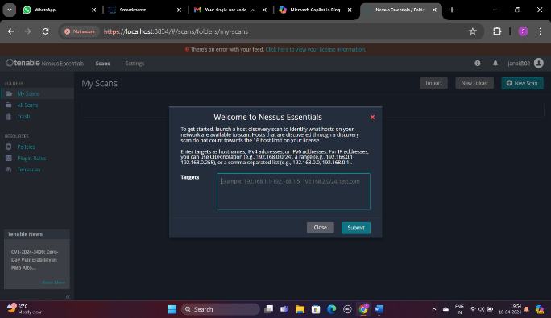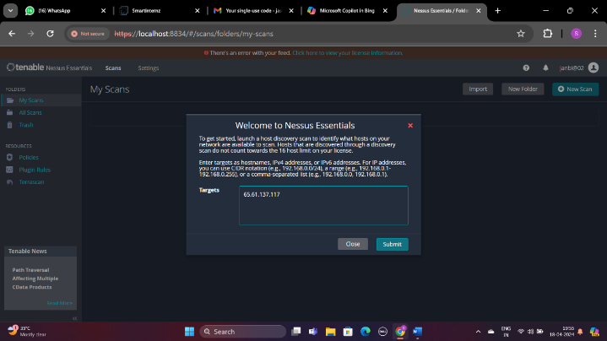

**Fig:7.1. Interface To Enter The Ip Address**

**Step2:-** After the step 1, we will get the interface like shown in the below figure where we could able to see the Ip option as well as DNS option. When we are selecting anyone of them both will be selected. After selecting we have to click on run scan in order to start the process of scanning.

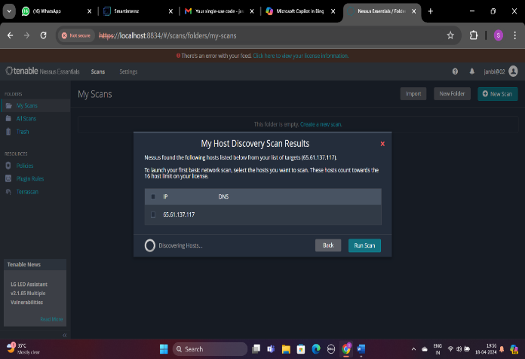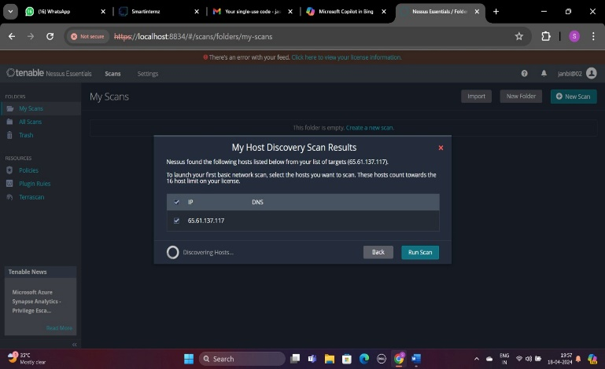

**Fig:7.2. Interface To Run Scan**

**Step3:-** After the step 2 , we can able to see that the scan has being processas shown in the below figure, the marked surface shows the percentage of the scanning being process as of now the percentage is **3,** We have to wait until it turns into 100 also to show the report.

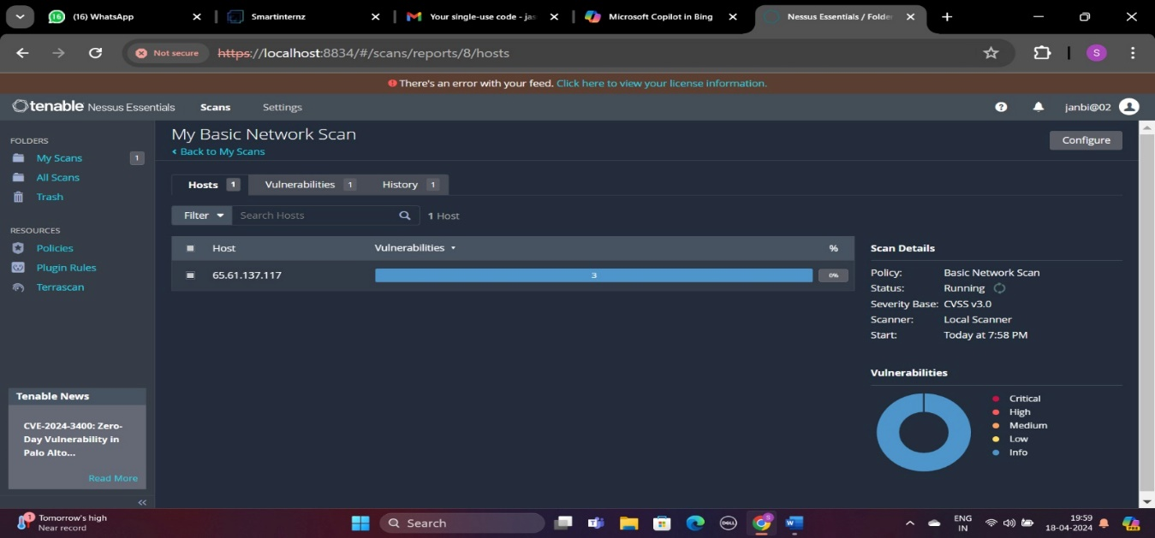

**Fig:7.3. Interface Showing The Percentage of Scanning**

**Step4:-** After the completion of the process it start to list the vulnerabilities that the website has with the severity level in the right most corner with necessary information like count, family, name, CVSS, etc. as shown in the given figures

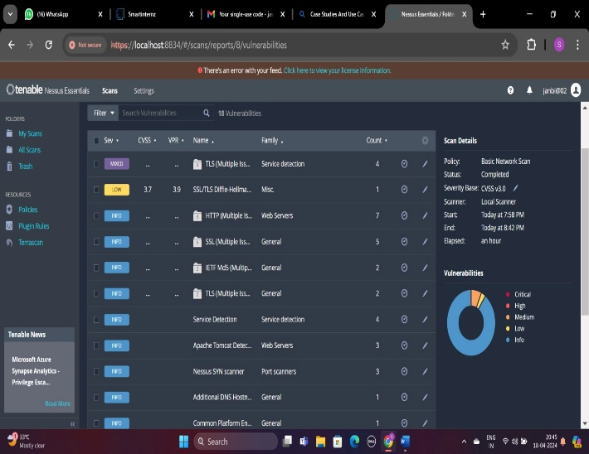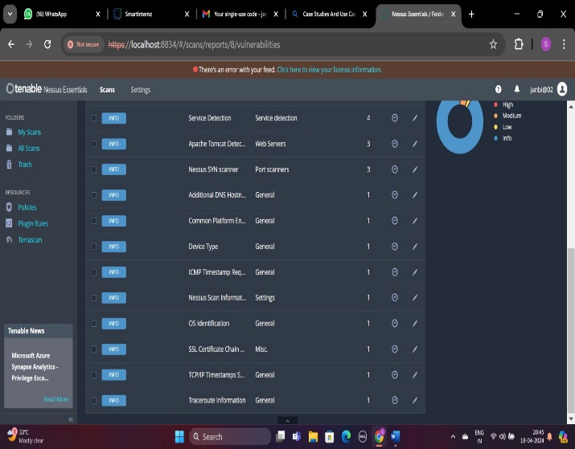

**Fig:7.4. Interface That Shows The Result Of The Scan Performed**

**Step5:-** On clicking on the mixed vulnerability as shown in the below figure we can able to explore the multiple vulnerabilities that it consists.

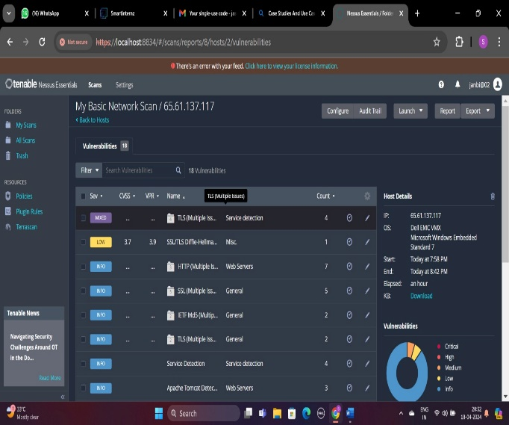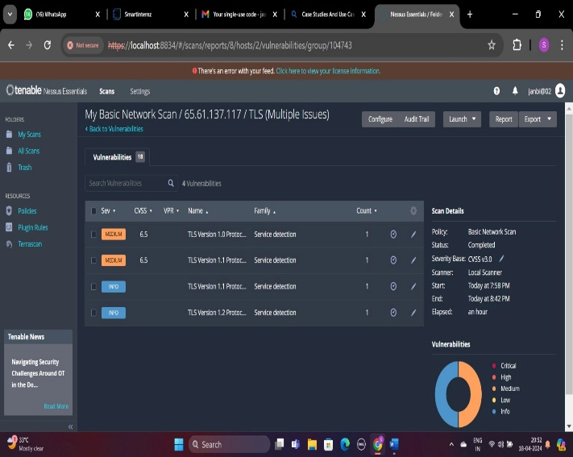

**Fig:7.5. Interfaces Before(Left Side) And After(Right Side) Clicking On The Mixed Vulnerabilities**

**Step6:-** After seeing the multiple vulnerabilities**,** On clicking on any one in the list, here we took the top one named as “medium” based on the severity to see the information regarding the particular vulnerability also with the solution to mitigate the vulnerability.

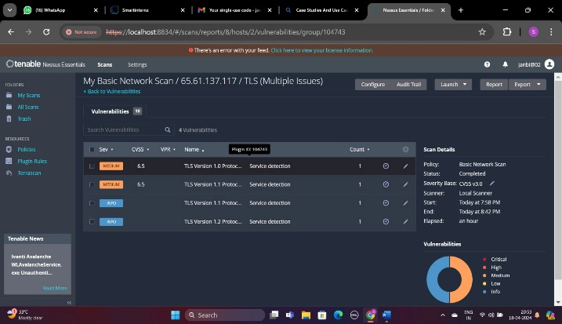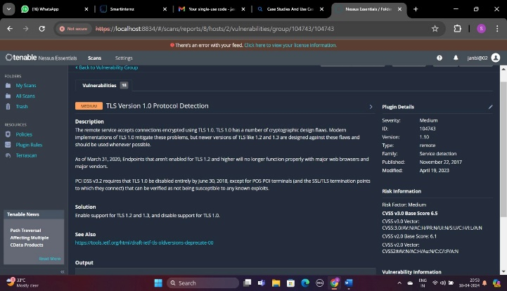

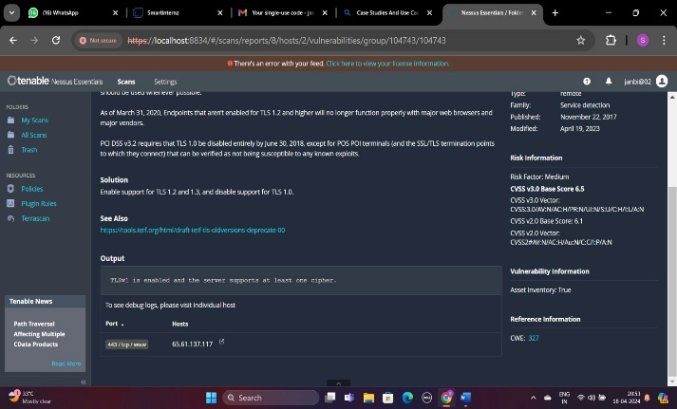

**Fig:7.6. Information About The Particular Website And Solution How To Mitigate Them**

**Step7:-**We can also be able to download the report from the Nessus Essentials itself with all the information we have to know before securing the sites after knowing the vulnerabilities.

For example:

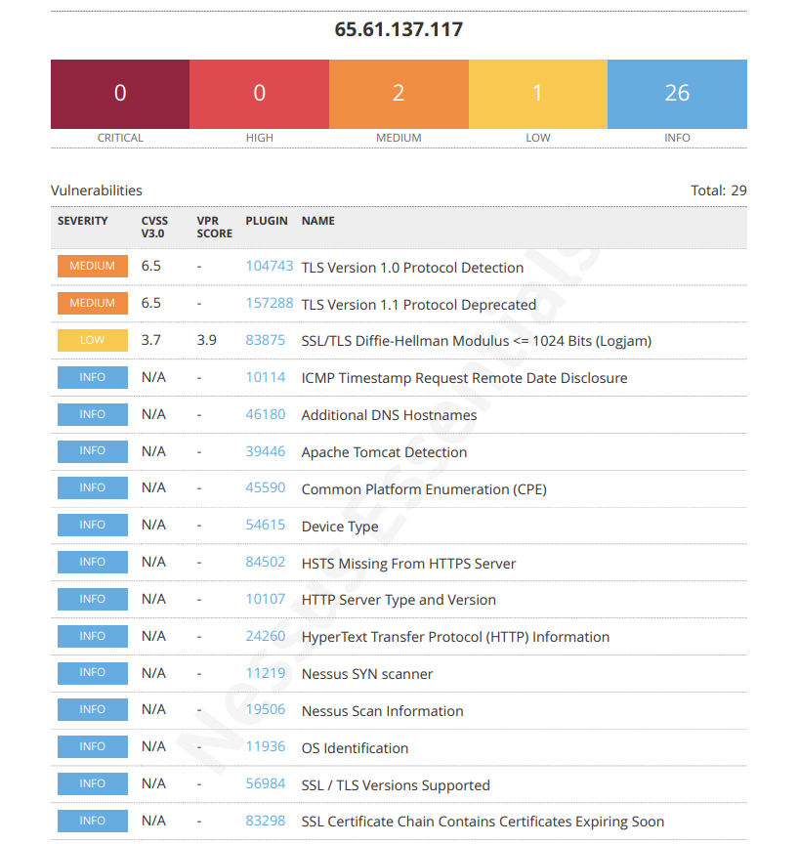

**Fig:7.7. Overlook Of The Report**

There are four types of formats in which we can get the reports, they are

* **Complete List Of Vulnerabilities by Host**

It gives the summary list of vulnerabilities for each host detected in the scan.

*To access the report, click the following link :* [*CLICK HERE!*](https://drive.google.com/file/d/1S1dxjMAvOl3vohs5PH5vs7dxq8PaByGb/view?usp=drive_link)

* **Detailed Vulnerabilities By Host**

It gives the present detailed vulnerabilities by host.

*To access the report, click the following link :* [*CLICK HERE!*](https://drive.google.com/file/d/1DNHpqzgEd37kP01BKlVCC7rPc8WwRY5F/view?usp=drive_link)

* **Detailed Vulnerabilities By Plugin**

It gives the present detailed vulnerabilities by plugin.

*To access the report, click the following link :* [*CLICK HERE!*](https://drive.google.com/file/d/1qT7q7felPX-gA017MpVe7I8jcw2Lc3jz/view?usp=drive_link)

* **Vulnerability Operations**

It lists the host and vulnerability details for each host detected in the scan.

*To access the report, click the following link :* [*CLICK HERE!*](https://drive.google.com/file/d/1UMwpmhAydMruEpHdEJ5PLyuExl2NXxzs/view?usp=drive_link)

**Step8:-** We can configure the scan furthermore as our need also we can able to select the plugins whatever we need. In order to perform the vulnerability scanning as our need for example: filtering certain ports, certain vulnerabilities, etc. The interfaces to configure the scan through scan options and plugin options are shown in the below figures.

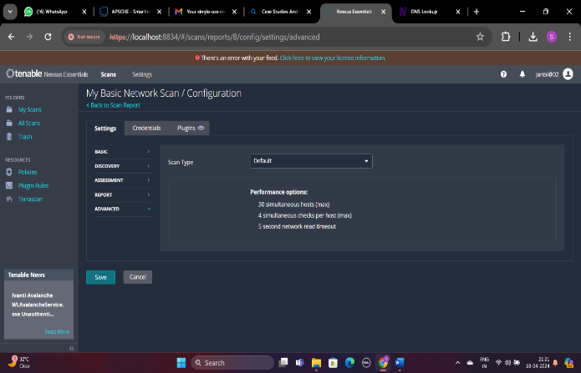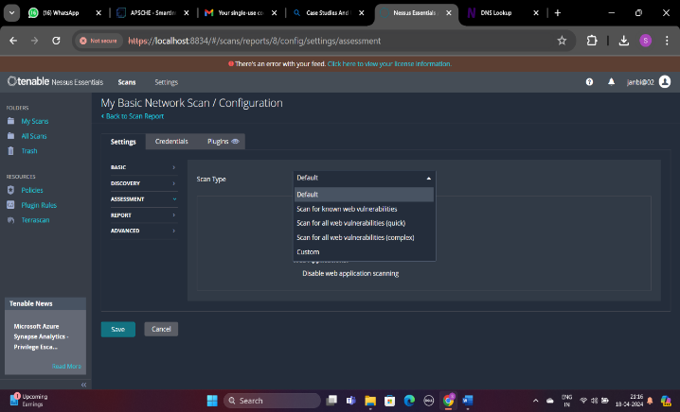

**Fig:7.8. Interface To Configure Through Scan Options**

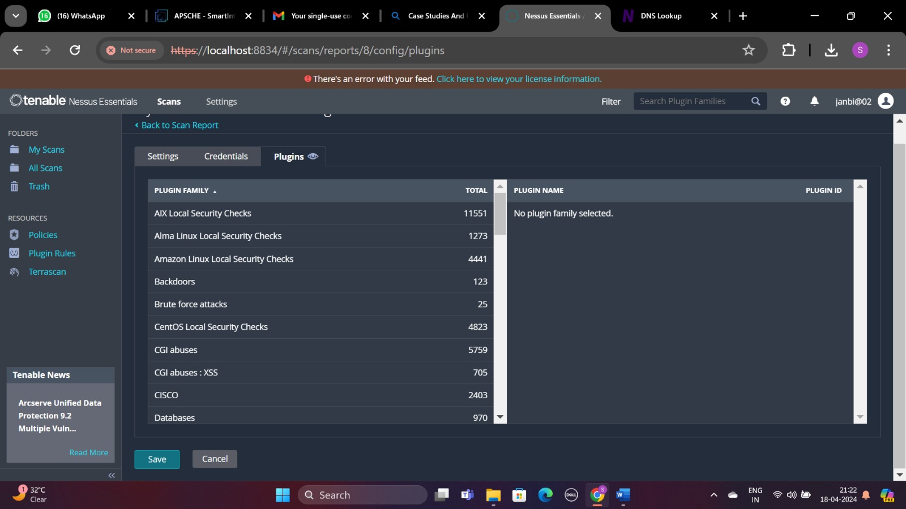

**Fig:7.9. Interface To Configure Through Plugins Options**

**PERFORMING VULNERABILITY SCANNING ON TARGET WEBSITE (**[**apsche.smartintenz.com**](https://apsche.smartinternz.com/)**)**

In this case all the steps are followed same as shown in the above vulnerability scanning of the practice website [www.altoromutual.com](http://www.altoromutual.com) , but instead of giving the Ip address we are giving Domain Name here in order to scan the vulnerabilities in the target website [apsche.smartinternz.com](https://apsche.smartinternz.com/). The proofs of concepts were shown below for the execution of vulnerability scanning for target website.

**Step3:-**

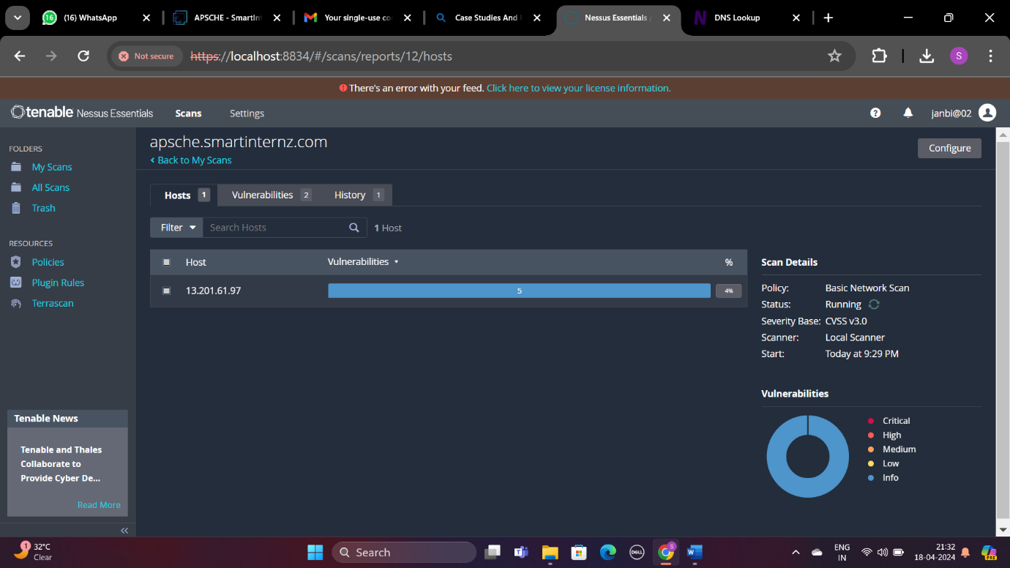

**Fig:7.10. Interface Showing The Percentage of Scanning**

**Step4:-**

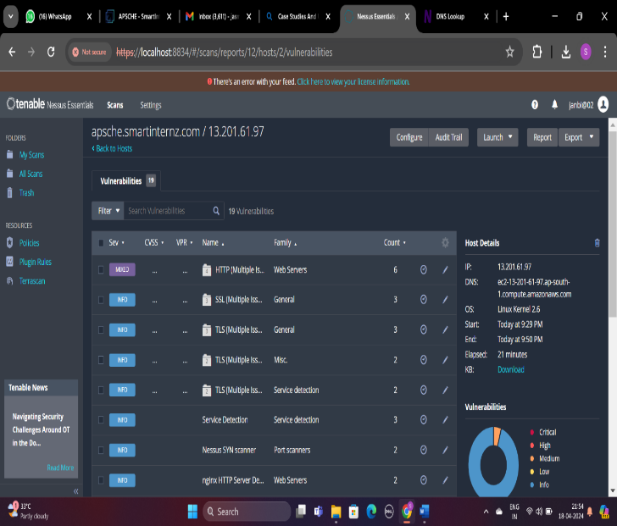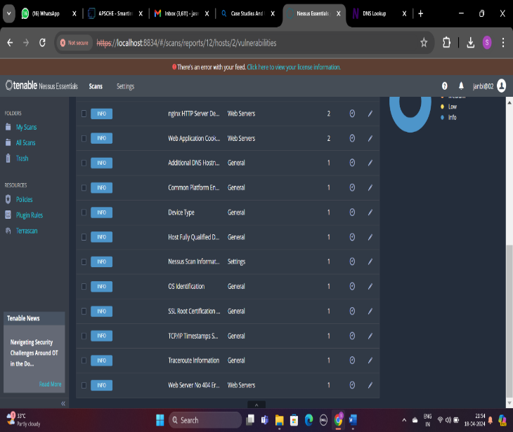

**Fig:7.11. Interface That Shows The Result Of The Scan Performed**

**Step5:-**

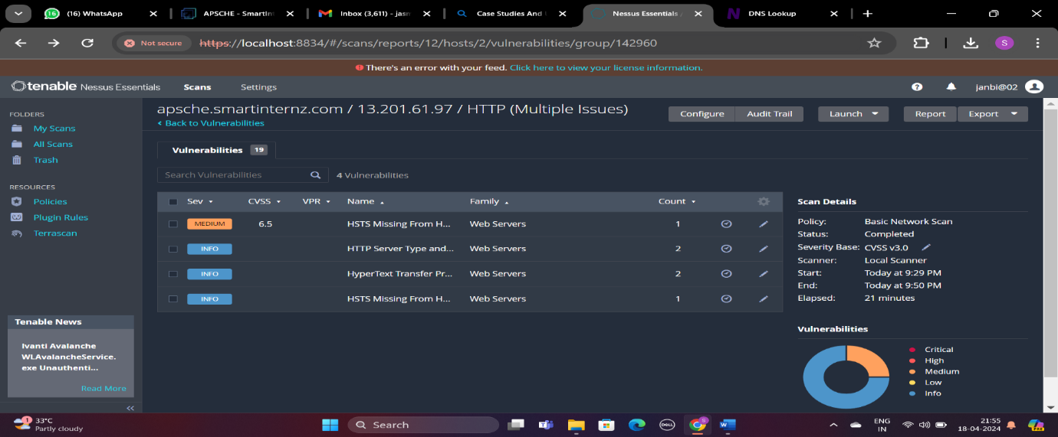

**Fig:7.12. Interface After Clicking On the Mixed Vulnerabilities**

**Step6:-**

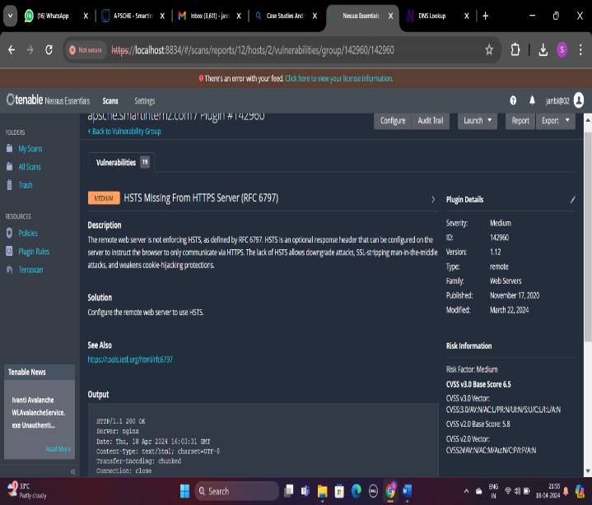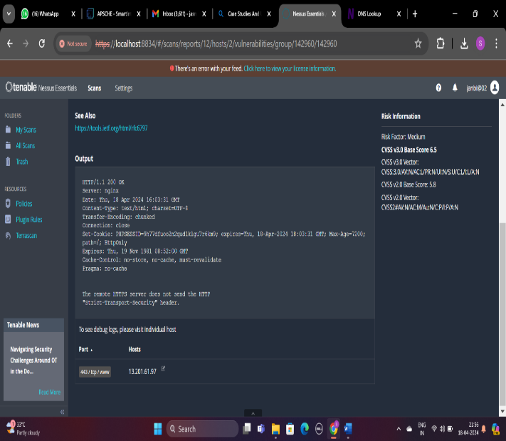

**Fig:7.13. Information About The Particular Website And Solution How To Mitigate Them**

**Step7:-** We can also able to download the report from the Nessus Essentials itself with all the information we have to know before securing the sites after knowing the vulnerabilities for the website i.e., [apsche.smartinternz.com](https://apsche.smartinternz.).

*To access the overall report, click on the following link :* [*CLICK HERE!*](https://drive.google.com/file/d/1QTQSsDDKPB694iX8Uc1fSUcSshqFB1VT/view?usp=drive_link)

**“Performing Vulnerability Scanning Using Nmap In Order To Show The Difference Between Nessus and Beyond Nessus”**

We took the practice site to go for vulnerability scan through Nmap i.e., [www.altoromutual.com](http://www.altoromutual.com). The Proof Of Concepts(POCs) of the execution of Nmap on practice website is shown below.

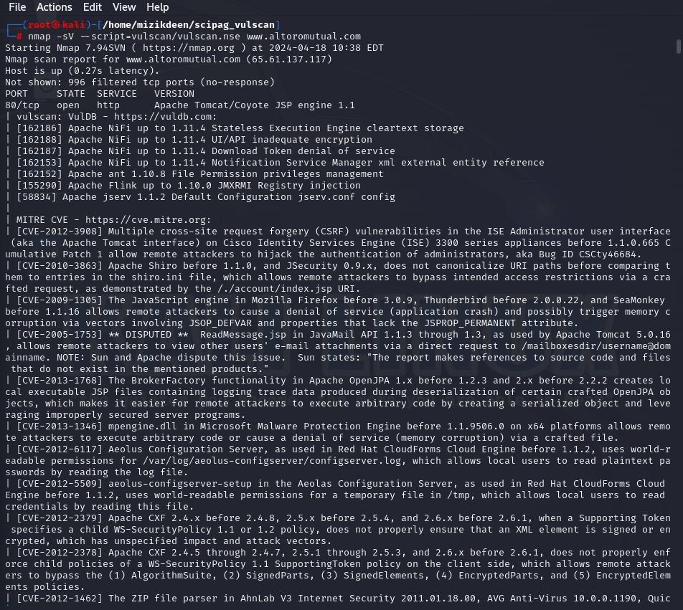

**Fig:7.14. Initiation Of Scanning**

The above figure shows that the conducting vulnerability scanning for the website [www.altoromutual.com](http://www.altoromutual.com) was successful and listing all the vulnerabilities that the website possess and the next figure that is shown below refers to the remaining vulnerabilities the website has.

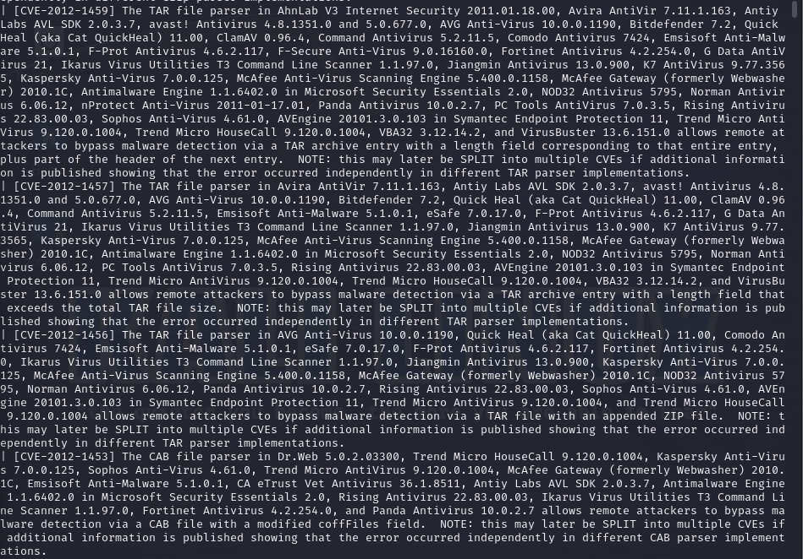

**Fig:7.15. List Of Vulnerabilities**

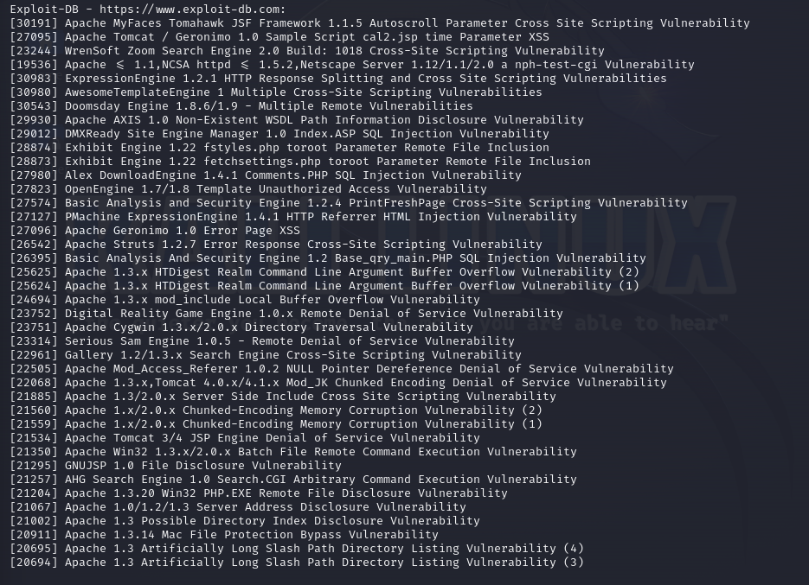

**Fig:7.16. Description About Vulnerabilities In www.exploit-db.com**

The above figure shows the relative article about the vulnerabilities that the site has, since the exploit-db is a google based vulnerability database which has the database of the vulnerabilities that has been identified recently, cleared, etc.

**RESULT**

We have successfully performed the vulnerability scanning for the both practice and target website using Nessus Essential tool and also got the precise report generated through it, also we have performed vulnerability scanning on practice website using Nmap in order show the difference between the features of both the Nessus Essential and Nmap to ensure that Nessus Essential is best among all other tools.

**8. CONCLUSION**

In this way, the vulnerability scanning is performed on the practice website called [www.altoromutual.com](http://www.altoromutual.com) and target website called [apsche.smartinternz.com](https://apsche.smartinternz.com/) by using Nessus Essential Vulnerability scanning tools which we have seen with so many effective and enhanced tools which makes the work so potent and fast as a security professional needed to be. Also we have performed vulnerability scanning in Nmap which is not as good as compared with the results came out from the Nessus.

To sum up, delving into Nessus and beyond in the pursuit of comprehending cyber threats uncovers a multifaceted and ever-changing environment. Nessus stands out as a state-of-the-art tool for managing vulnerabilities, providing a sturdy and adaptable solution for entities of all sizes. It shines in the areas of network discovery and asset recognition, ensuring thorough scans that pinpoint potential vulnerabilities that cyber threats could exploit. Nessus also offers sophisticated features for auditing compliance, aiding organizations in meeting regulatory requirements. Its accurate prioritization of vulnerabilities enables effective remediation strategies, directing resources towards the most pressing issues first. Moreover, Nessus can smoothly blend into an existing cybersecurity framework, promoting cooperation and simplifying security procedures.

Nessus’s capabilities for continuous monitoring and evaluation provide real-time visibility into a network’s security status, surpassing the scope of single-instance scans. This ensures that organizations are always prepared to adjust to emerging cyber threats. In addition, Nessus produces detailed reports, facilitating the tracking of cybersecurity advancements, conveying findings to stakeholders, and demonstrating compliance to auditors. Beyond Nessus, it’s vital to understand the landscape of cyber threats. Cyber threats are in a constant state of evolution, and there’s no universal solution for determining what a cyber threat might mean for different organizations. Nonetheless, understanding and prioritizing cyber threats for remediation is an excellent initial step in creating a cybersecurity program.

In short, tools like Nessus and a broader understanding of cyber threats are essential to effective vulnerability management and the strengthening of digital defenses. They enable us to detect and fix vulnerabilities, safeguarding our systems from malicious attacks. Hence, the journey of understanding cyber threats and exploring Nessus and beyond is not merely about utilizing a tool, but about constructing a robust and flexible cybersecurity infrastructure.

**9. FUTURE SCOPE**

In summary, the future of comprehending cyber threats and delving into Nessus and beyond is tied to the ongoing advancement of vulnerability scanning technologies and methodologies. Here are some prospective trends and scopes:

* **Artificial Intelligence and Machine Learning**: AI and machine learning are anticipated to have a significant impact on vulnerability scanning. These technologies can enhance the precision of vulnerability detection and minimize false positives, thereby streamlining the scanning process.
* **Integration with Other Security Practices**: The integration of vulnerability scanning with other security practices, such as penetration testing, is expected to become more prevalent. This integration can offer a more holistic view of an organization’s security stance.
* **Continuous Monitoring and Real-Time Threat Intelligence**: The demand for continuous monitoring and real-time threat intelligence is projected to rise. This will enable organizations to stay abreast of emerging threats and adjust their security measures as needed.
* **Automation and Scalability**: As organizations expand and their networks become more intricate, the requirement for automated and scalable vulnerability scanning solutions will grow.
* **Regulatory Compliance**: With the growing focus on data security and privacy, regulatory compliance will remain a key motivator for vulnerability scanning. Regular vulnerability scanning can assist organizations in demonstrating compliance with regulations such as NIST, PCI DSS, and HIPAA.
* **Market Growth**: The global vulnerability scanning market is predicted to experience substantial growth in the upcoming years. This signifies a rising awareness of the importance of vulnerability scanning in maintaining cybersecurity.

In conclusion, the future of comprehending cyber threats and delving into Nessus and beyond involves harnessing advanced technologies, integrating security practices, and adapting to the changing cyber threat landscape. This will empower organizations to proactively detect and rectify vulnerabilities, thereby bolstering their cybersecurity posture.

**REFERENCES**

1. <https://medium.com/@itdanny/unleashing-cybersecurity-prowess-exploring-tenable-nessus-feced4b3cd37>
2. <https://medium.com/@careertechnologymiraroad/mastering-network-security-a-deep-dive-into-nessus-vulnerability-scanner-31b2b2036808>
3. <https://owasp.org/www-community/Vulnerability_Scanning_Tools>
4. <https://www.knowledgehut.com/blog/security/nessus-scanner>
5. <https://blog.netwrix.com/2023/04/07/top-5-vulnerability-management-best-practices/>
6. <https://www.silk.security/vulnerability-management-lifecycle/vulnerability-management-process>
7. en.wikipedia.org. https://en.wikipedia.org/wiki/Nmap
8. <https://www.tecmint.com/nmap-network-security-scanner-in-kali-linux/>
9. <https://www.cyberpratibha.com/blog/nmap-commands-in-kali-linux-with-example/>
10. <https://www.simplilearn.com/cyber-security-use-cases-article>